**Individual Research Paper:**

Using Naive Bayes Algorithm of Machine Learning in Forecasting Air Quality

**BCIS**

**Aug 15th 2018**

**Title**: Using Naive Bayes Algorithm of Machine Learning in Forecasting Air Quality

**Research question**: How effective is the Naive Bayes algorithm in forecasting?

**Subject**: Computer Science

**Word count**: 3804

**Table of Contents**

1. Introduction 4

1.1 Machine Learning Background 4

1.2 The Naive Bayes Algorithm Background 5

1.3 Challenges with using Naive Bayes Algorithm To Forecast 7

1.4 Air Quality & Air Quality Forecast 8

2. Investigation 10

2.1 Data Analysis 10

2.2 Building The Forecast Algorithm 16

2.3 Effectivity of Naive Bayes in Forecast 20

3. Conclusion 22

4. Works Cited 24

4.1 Works Cited 24

4.2 Works Consulted 26

5. Appendices 27

5.1 Whole Dataset After Data Cleansing 27

# Introduction

### 1.1 Machine Learning Background

To fully explore the research question “How effective is the Naive Bayes algorithm in forecasting?”, it is essential to gain an understanding of study of machine learning where Naive Bayes belongs to.

As computer systems are required to complete more complex procedures and operations, machine learning comes into the scope. It is a sub-branch of artificial intelligence that focuses on programming computer through supervised learning, unsupervised and reinforcement learning, and ultimately let computers to make its own decisions without being explicitly programmed. (Rouse)

Supervised learning is when computer is given a large quantity of data on the input and the output in pairs. The computer then recognizes a pattern and forms parameters for future inputs. (Ng) This essay is heavily based on supervised learning, showing through the forecast algorithm. Unsupervised learning, on the other hand, is when computer is given a dataset with inputs but without the outputs as references. The computer then needs to develop patterns from the dataset and expect several outputs. This type of learning has a bigger chance to tackle accidental outputs. (“Unsupervised Learning”) Reinforcement learning is another important type of learning in machine learning where computer systems learn by performing actions in an environment and seeing the consequences of the actions. (Simonini) The computer then evaluates the consequence and hence improves itself to prepare for the next action. In this case, the input is both the data and the consequences of actions, and the output is the actions.

The ultimate goal is to give machines the ability to make decisions independent of humans by using vast amount of data. A good example of all three types of learning is the Deep Learning Project of Google called Alpha Go, which played chess against itself and discovered chess strategies merely by itself, and ultimately beat Korean chess master.

### 1.2 The Naive Bayes Algorithm Background

After basic knowledge of Machine Learning, the cores of Naive Bayes algorithm will make more sense. Naive Bayes algorithm is a Machine Learning algorithm that is designed to classify data. This algorithm uses the mathematical theory Bayes’ Theorem as core to make strong assumptions on which category does a piece of data belong to, and then it improves these assumption to achieve optimal categorization. Furthermore, Naive Bayes algorithm has a central assumption that all features in the data set are independent of each other (VanderPlas).



**Figure 1. Mattbuck. “Bayes' Theorem MMB 01.” Bayes' Theorem, Cambridge, 17 June 2009, en.wikipedia.org/wiki/Bayes%27_theorem.**

First off, there is the Bayes’ Theorem, which is the core of Naive Bayes algorithm. This theorem is defined as a formula (Figure 1.), and can be interpreted as the following:

The probability of event A happening given event B happens already can be calculated by the probability of event B happening given event A happens already times the probability of event A happening (Regardless of other events) all divide by the probability of event B happening (Regardless of other events).

The Bayes’ Theorem helps to calculate probability of an event in a reversed way to the ordinary probability calculations. This theorem can be best applied when something already happens (Event A), to calculates the probability of Event A happening when Event B happens before Event A.

The Naive Bayes algorithm builds upon this theory, and uses all features independently that contribute to the likelihood of the conclusion. For example, if orange is defined as three separate features that are orange, sphere-like, and has a rough surface, the Naive Bayes algorithm will classify orange as these three features. Then the computer is given a lot of samples that are called the training data to let the computer form parameters. These parameters are rules the computer can develop through analysis of the training data. The computer then follows these parameters when given a new sample of fruit, and makes the decision. The Naive Bayes algorithm calculates probabilities against each feature the user has chosen. In this case, the features are orange colour, sphere-like, and has a rough surface, which can correspond to event A, B, C for better comprehension. The Bayes’ Theorem then comes into the scope, and allows the computer to calculate the maximum likelihood of the new sample being an orange under the condition that event A, B, C already happens. The most widely accepted use of Naive Bayes algorithm is to filter and detect spam emails, which works under the same concept as the above example. However, this essay breaks the traditional uses of Naive Bayes and applies its algorithm in forecasting, which is exhilarating.

There are a lot of mathematics, specifically statistics, involved in Naive Bayes algorithm, and this essay will be focusing on the algorithm and computer science aspects of it.

### 1.3 Challenges with using Naive Bayes Algorithm To Forecast

When discussing “How effective” questions, it’s salutary to have a brief idea of the challenges when it comes to the use of Naive Bayes algorithm in forecasting. While Naive Bayes algorithm is a very stable and a non-rigid classifier, there are still problems and risks. First of all, the essay will not research into the actual field that studies air pollution, meaning that the meteorological side of the issue will not be reached due to that this is a computer science research. This means the accuracy of this algorithm can be influenced to some extent. Moreover, Naive Bayes is based on the assumption that all features are independent of each other, but from common sense it is known that many features in the natural world actually impose strong impacts on each other, known as correlations. For example, humidity is strongly bonded with precipitation, and air temperature also influences air pressure (Higher temperature means lower air pressure). This might also become a hindrance in the process of forecast.

### 1.4 Air Quality & Air Quality Forecast

When testing the effectiveness of Naive Bayes algorithm in forecasting, it is definitely interesting to use air quality as the forecast output as well as the measure of success since it has plenty of connections with people in their daily lives. As the world industrialize, many sources such as factories produce hazardous pollutants and create air pollution. Air pollution is especially severe in China, often getting to the point where it’s hazardous to do outdoor activities. AQI, referring to the Air Quality Index, is a world wide standard of presenting the severity of air pollution. Until now, there are only a few people who have tried to use Machine Learning in air forecasting, and it’s unprecedented to use Naive Bayes algorithm in air forecasting. The forecast will be very useful, when successfully created, for giving accurate predictions on whether people can do outdoor activities or not, also helping people to plan schedules ahead of time. The algorithm will take in 11 factors that are strongly related in severity of air pollution (Listed below). This essay uses Python as the programming language in building the Naive Bayes algorithm and tests the applications of Naive Bayes in general forecast.

Factors to consider in building the forecaster:

* PM2.5 (μg/m3): Daily averaged concentration of PM2.5
* PM10 (μg/m3): Daily averaged concentration of PM10
* SO2 (μg/m3): Daily averaged concentration of SO2
* CO (μg/m3): Daily averaged concentration of CO
* NO2 (μg/m3): Daily averaged concentration of NO2
* O3 (μg/m3): Daily averaged concentration of O3
* P Mean (hPa): Mean barometric pressure
* T Mean (℃): Mean air temperature
* H Mean (%): Mean relative humidity
* Pre (mm): Precipitation
* V Mean (m/s): Mean wind velocity

The range of AQI measurement is shown in figure below:

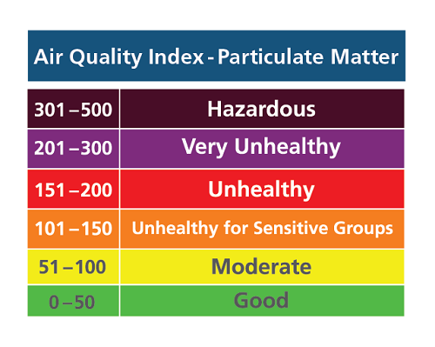

**Figure 2. “Air Quality Index - Particulate Matter.” Spare The Air, www.sparetheair.com/aqi.cfm.**

To clarify, the algorithm will not forecast to the exact value of air pollution but the 6 levels of air pollution (Figure above). The accuracy of the algorithm will be tested using another simple algorithm which will be explained further. Basically, the accuracy testing algorithm will take all correctly forecasted results and divide by the sample size and ultimately obtain a percentage that presents the accuracy.

A wide range of appropriate and relevant sources are chosen according to the field of study.

# 2. Investigation

Before building the algorithm (Or model), an essential procedure is data analysis. In order to collect and organize big data, several data analysis strategies are needed.

### 2.1 Data Analysis

Data analysis can be broken down into parts. First, there is the collection of data. All data are collected from two databases (“北京空气质量指数”) (“Beijing Capital”).

All data are then put into a table shown below that includes a whole year of data from 2017 July to 2018 July:

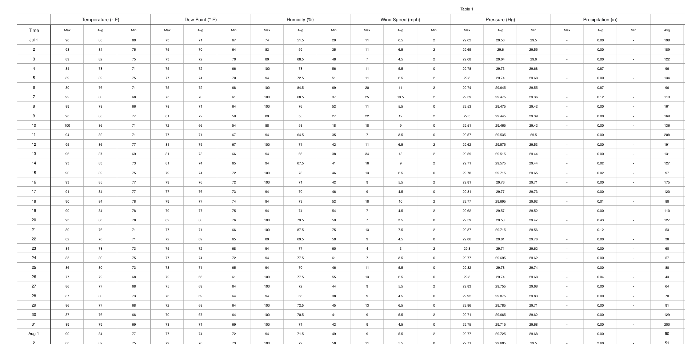

**Figure 3.**

Afterward, there is the data cleansing. The figure above only shows a portion of the table due to spacing (Full table see appendix). This table above collected data on several independent variables. The table incorporated data on all of the five features considered previously in the introduction of the essay (Temperature, dew point…), and the data begins from July 1st 2017 until July 31st 2018. There is also the dependent variable that is the level of air pollution, which is the outcome of the table since the essay is using features to forecast air pollution. Roughly 70% of the data will be used as training data that trains the computer and formulates the parameters. The rest of the data will be testing data that tests the accuracy of the forecast. Additionally, “Previous” refers to the previous day.

Then, use Numbers’ functions of calculating the averages, all averages are calculated and filled in.

Since the ultimate goal is to forecast the level of air pollution, not the exact value, data cleansing was done to categorize each exact value of AQI into a specific level (As previously mentioned, 6 levels in total):

1. Create 6 more columns after the AQI Avg column, each represent a level of air pollution, and another column after that for the final result. (Figure 4.)
2. Write a simple line of code in the Numbers app by pressing “=“ button (Figure 4.). This algorithm calculates: if the AQI value is smaller than 51, then list it as 1 (All values listed as 1 will fit into the boundary of “Good” in the AQI level table), and any value larger than or equal to 51 will be listed as 0 for future categorizations.
3. Write another line of code (Figure 5.) that calculates: if the AQI value is larger than 50 and smaller than 101, then list it as 2 (All values listed as 2 will fit into the boundary of “Moderate” in the AQI level table), and any value that does not meet the condition will be listed as 0 for future categorizations.

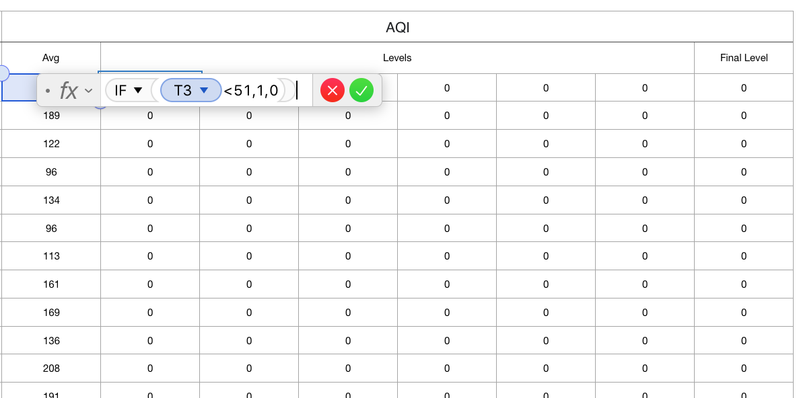

**Figure 4.**

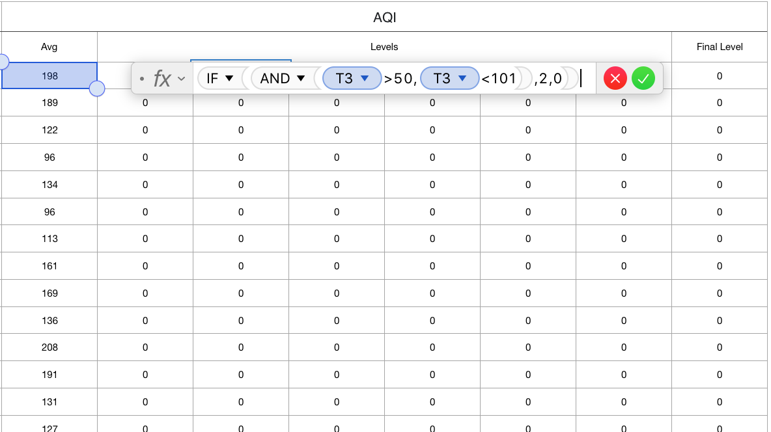

**Figure 5.**

1. This line of code calculates (Figure 6.): if the AQI value is larger than 100 and smaller than 151, then list it as 3 (All values listed as 3 will fit into the boundary of “Unhealthy to sensitive groups” in the AQI level table), and any value that does not meet the condition will be listed as 0 for future categorizations.
2. This line of code calculates (Figure 7.): if the AQI value is larger than 150 and smaller than 201, then list it as 4 (All values listed as 4 will fit into the boundary of “Unhealthy” in the AQI level table), and any value that does not meet the condition will be listed as 0 for future categorizations.

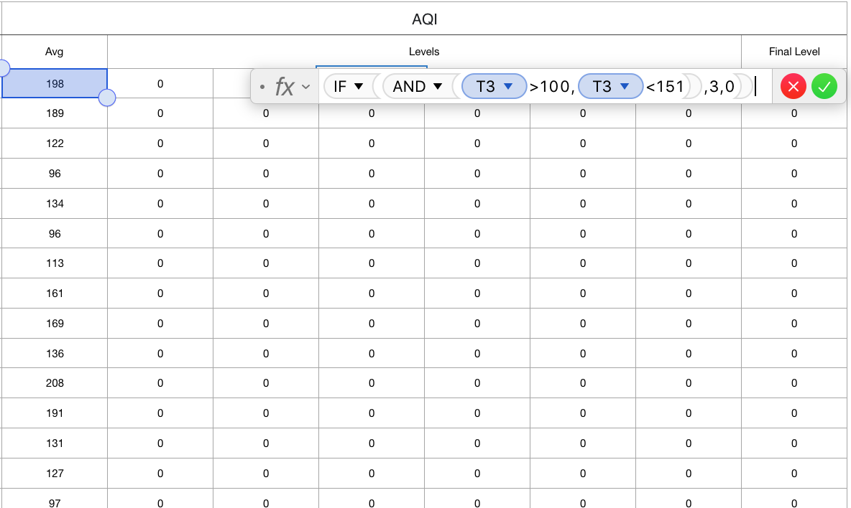

**Figure 6.**

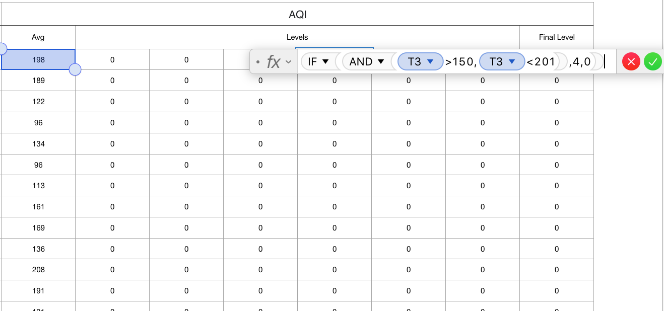

**Figure 7.**

1. This line of code calculates (Figure 8.): if the AQI value is larger than 200 and smaller than 301, then list it as 5 (All values listed as 5 will fit into the boundary of “Very Unhealthy” in the AQI level table), and any value that does not meet the condition will be listed as 0 for future categorizations.

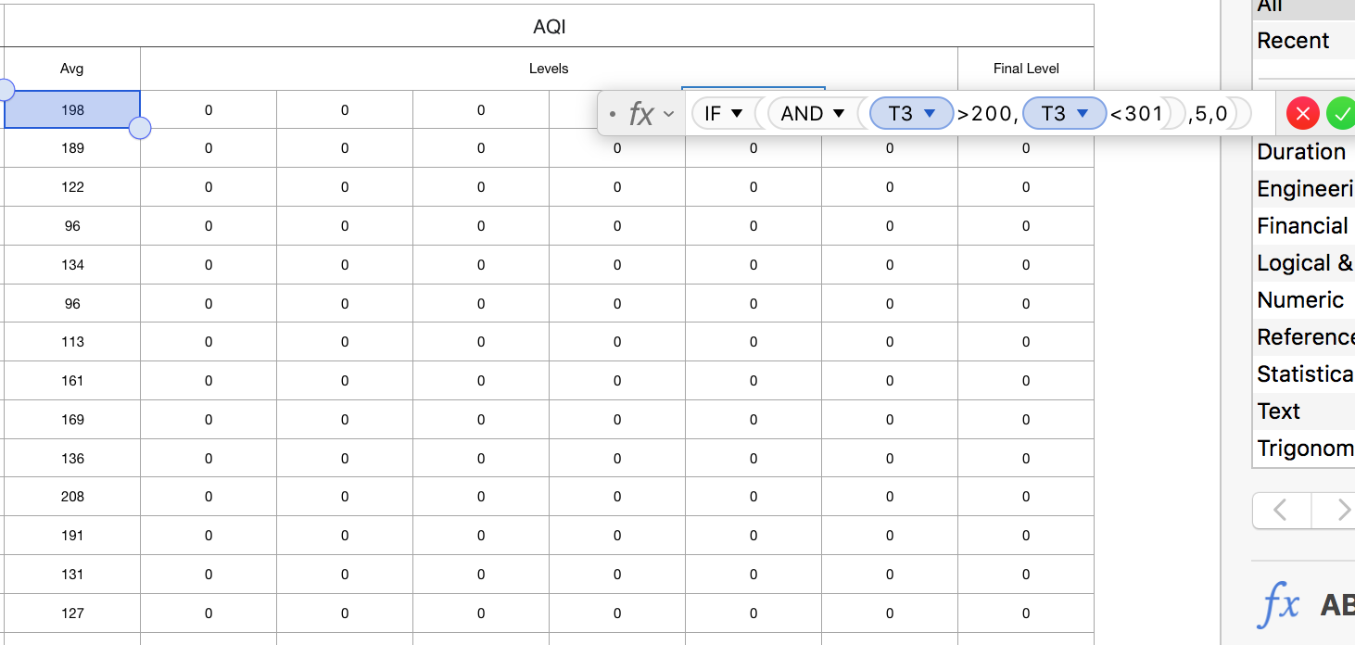

**Figure 8.**

1. This line of code calculates (Figure 9.): if the AQI value is larger than 300 and smaller than 501, then list it as 6 (All values listed as 6 will fit into the boundary of “Hazardous” in the AQI level table), and no values will be left out in the AQI Avg column.

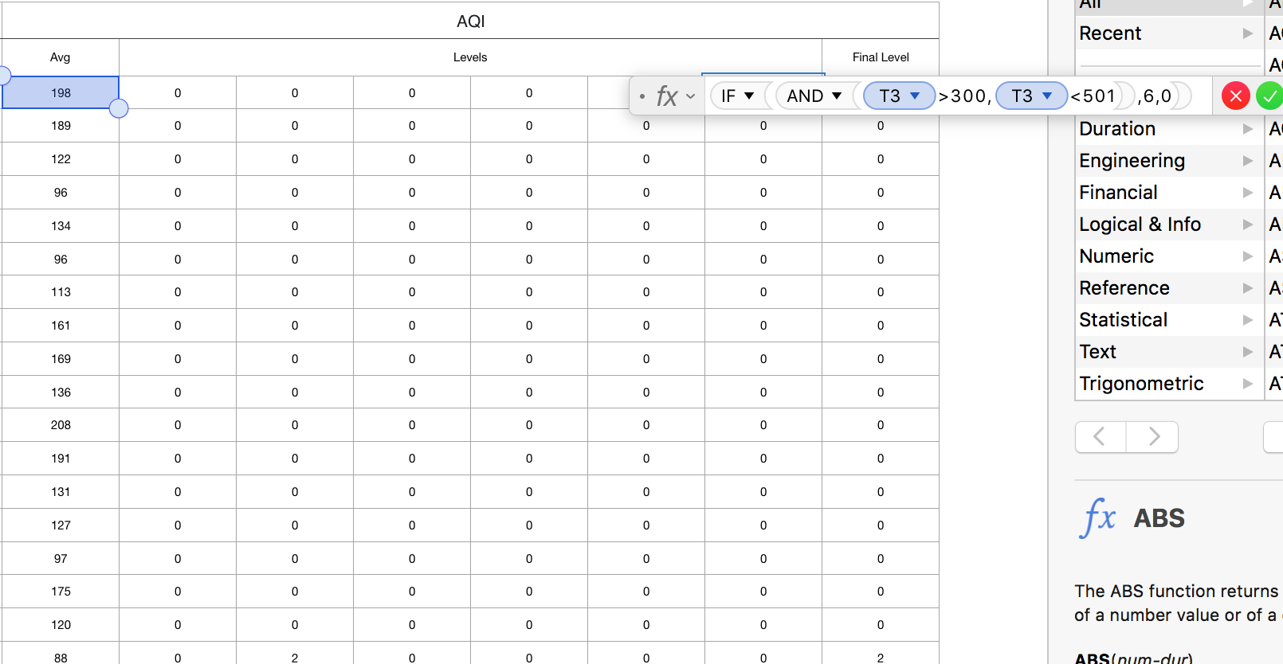

**Figure 9.**

At this point, every line below the “Levels” column should has one number between 1-6. Using the sum function, calculate the sum of each line, which will present the numbers in each line since all other numbers are 0s (Figure 10.).

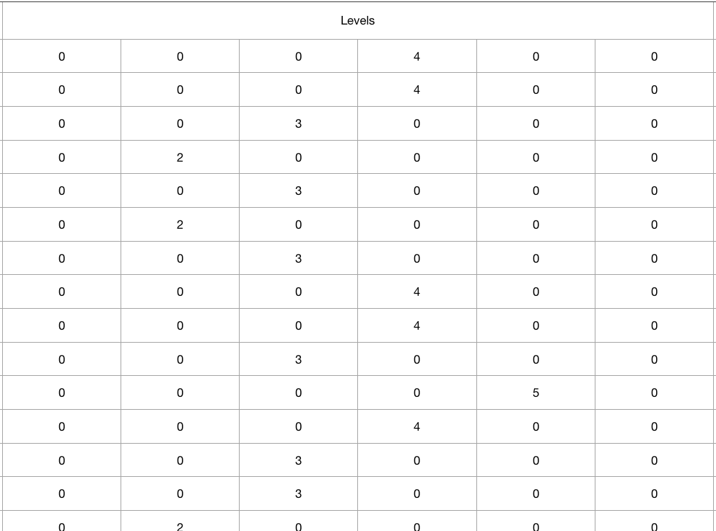

**Figure 10.**

The last step is to delete any unnecessary columns such as the maximum and minimum of these features. A finished table is shown below in figure 11. The table is exported as “.csv” for access.

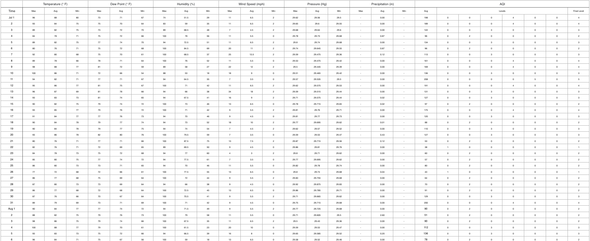

**Figure 11.**

### 2.2 Building The Forecast Algorithm

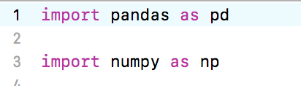

**Figure 12.**

First, Pandas DataFrame is a tool kit that is specifically designed to work with 2-dimensional data structures such as table, list, arrays, etc. Since this essay records the weather data as a table, Pandas DataFrame is an extremely strong tool to incorporate. The first line of command above imports the pandas tool kit as “pd”, so that the programmer can simply call the tool kit by the name “pd”. The line of command on line 3 imports an important package that is NumPy. This package is essential for scientific computings with the programming language Python (“NumPy”). Again, the NumPy package is imported as “np” for easier access.

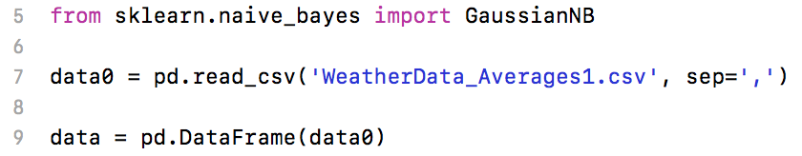

**Figure 13.**

This command line on line 5 imports the core of this essay, the Naive Bayes algorithm package. This is a finished package of Naive Bayes algorithm open for any users to use. The sklearn stands for scikit-learn, and it is a simple, effective platform and database consisted of data mining and analysis, a brilliant source of existing algorithms and data sets. This paper is, in this case, importing the Naive Bayes algorithm from the sklearn database.

After Naive Bayes algorithm is imported, import GaussianNB from it. The Naive Bayes algorithm has 3 main parts, which are GaussianNB (NB = Naive Bayes), MultinomialNB, and BernoulliNB. This essay will be using GaussianNB (As shown in the algorithm) because GaussianNB is specifically built for classification purposes. The other two, Multinomial and Bernoulli, are designed for multinomial distributed data and data that are distributed according to multivariate Bernoulli distributions, respectively (“1.9 Naive Bayes”). These two are irrelevant in this essay and will not be further discussed. Back to the algorithm, the command line on line 5 does the job of importing GaussianNB tool kit from Naive Bayes algorithm from sklearn database (sklearn.naive_bayes).

The command line on line 7 reads the finished table of dataset and separates with commas between. This document is named as “data0” in the algorithm. The command line on line 9 then converts the “data0” csv document into the format of Pandas DataFrame, naming it as data (“如何将pandas.dataframe”).

**Figure 14.**

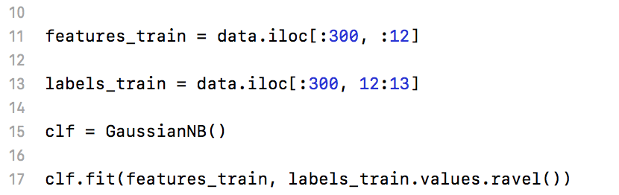

The command line on line 11 selects the training data for all inputs data from first row to 300th row, first column to 12th column. The command line on line 13 selects the training data for all outputs data from first row to 300th row, and 13th column. The inputs data are the features in the table, and the output data is the AQI on each day. This action only selects the data.

Command line on line 15 simply saves the GaussianNB function as clf for convenience when calling. The command line on line 17 trains all data and starts to formulating parameters for future testings. As mentioned, this is a type of supervised learning where users give input and output to the computer. The computer will consequently see what kind of inputs creates particular outputs.

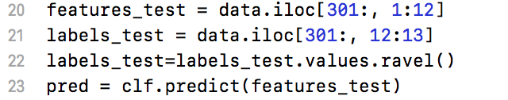

**Figure 15.**

The command line on line 20 selects the rest of the dataset, which is roughly 100 days, for the inputs to test the accuracy of the forecast algorithm. The command line on line 21, likewise, selects the same dataset for the output. The skipped lines are programmer notes reminding the usage of some commands, which is irrelevant and will not be discussed.

Since the table has values that are numbers and floats, the command line on line 22 turns all values into the same format. The next line of command takes in all the inputs and starts to forecast the outputs.

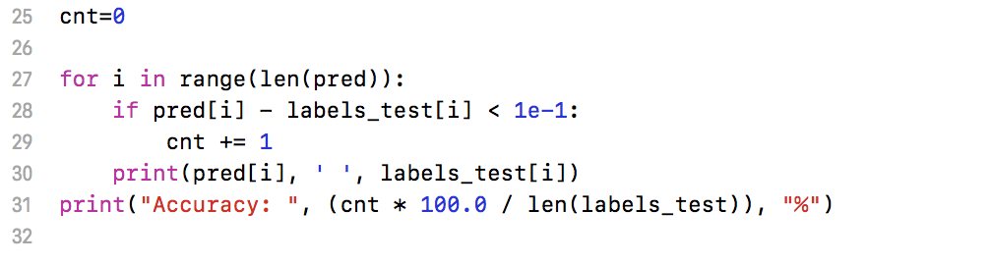

**Figure 16.**

The line of command “cnt=0” records the number of times that the forecast accurately predicts the output. The cnt needs to be set to 0 when the loop did not start yet. First, the For Loop iterates through all the data in the dataset and executes the prediction for each, knowing that the predict function is saved as “pred” (Line 23 in figure 15.). Each time the For Loop iterates, the cnt will plus one when the prediction is accurate and will maintain the same otherwise. Lastly, the algorithm takes the value of cnt times a hundred (To get a percentage) and divides by the size of the whole dataset to get the accuracy rate.

What this algorithm prints out is shown below:

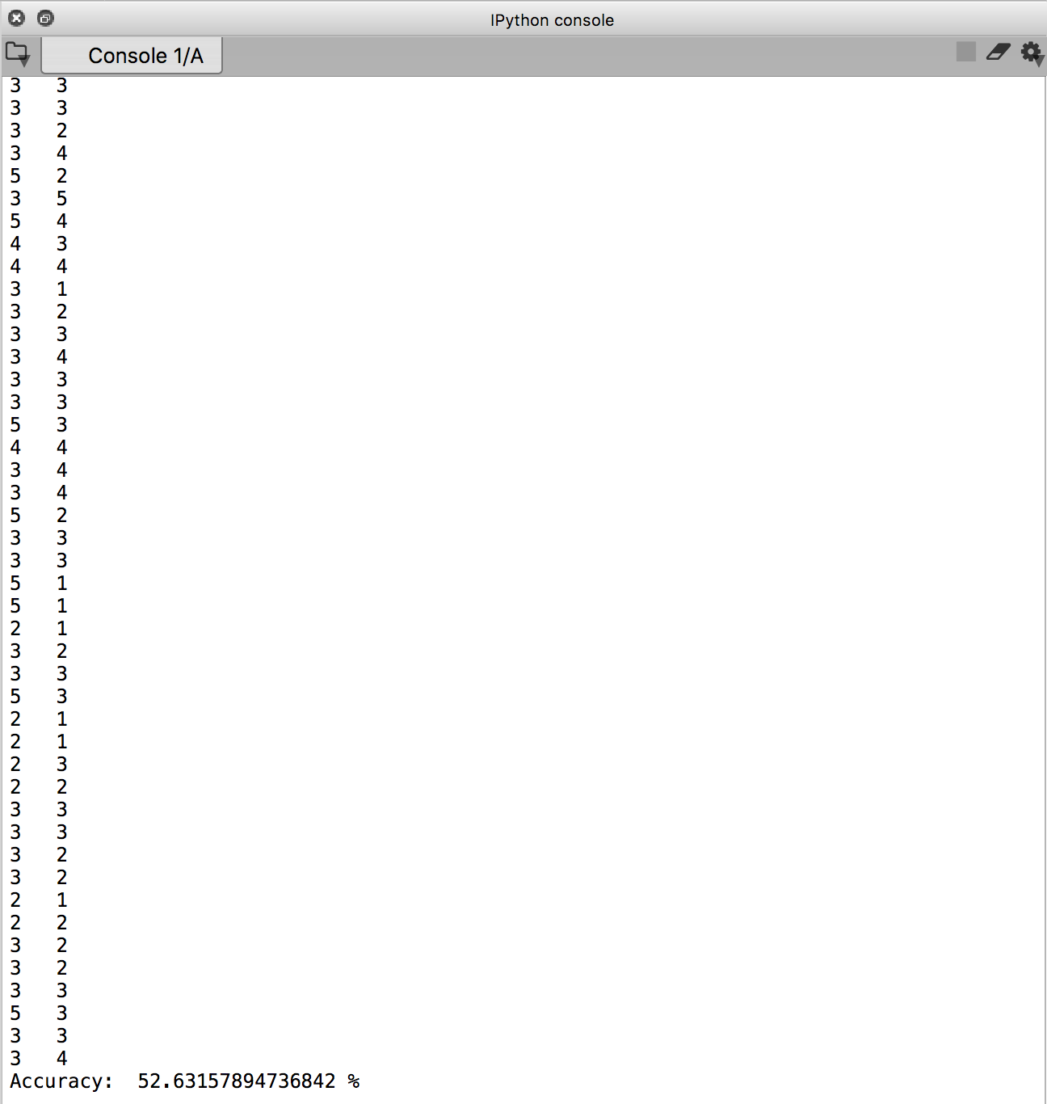

**Figure 17.**

The percentage of accuracy is around 53%, a very decent level of accuracy in area of forecast. Apart from the reason that air pollution is very hard to actually forecast since there are many accidental and artificial reasons, let’s look at how the effectiveness of the algorithm is affecting the accuracy.

### 2.3 Effectivity of Naive Bayes in Forecast

To begin with, the Naive Bayes algorithm is very effective under the condition that all features are independent of each other. Going back to this assumption, it is known from common sense that this condition does not always apply. Nearly every situation has features that are interconnected with each other, it is inevitable. This assumption does not necessarily make an impact on the result of Naive Bayes algorithms because Naive Bayes calculates every individual feature against the expected output, which means all inputs are independently treated. When all inputs are independently treated against the output, the importance of influence between inputs diminishes, and consequently the influence of inputs together on the output will reveal. However, in cases where features actually have great correlations between each other, Naive Bayes algorithm might start to create deviations. In order to get an overview on the correlation between features in the dataset, we use a function in the Pandas DataFramed package that previously imported.

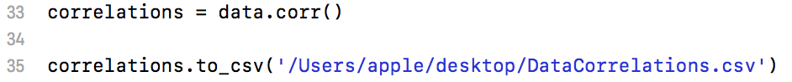

**Figure 18.**

The command lines in figure 18 uses .corr() function in the package to calculate the correlations, then converts to a csv formatted table and saves the file to the desktop, naming it “DataCorrelations.csv”.

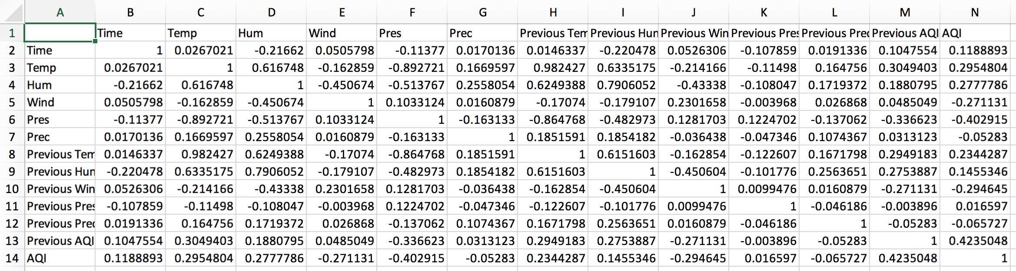

**Figure 19.**

With -1 being the largest negative correlation, 0 being no correlation, and 1 being the largest positive correlation, this function presents correlation between all features in figure 19. Notably, the strongest correlation is shown between air pressure and temperature when only looking at the five main features. When looking at the whole table, some strong correlations are between air pressure and temperature, air pressure and humidity, humidity and temperature, temperature and previous temperature, previous temperature and air pressure, previous temperature and humidity, previous humidity and humidity. This shows that the Naive Bayes algorithm has a huge disadvantage against this dataset when several strong links are present between features. This is against the central assumption of Naive Bayes and might cause impacts. In the algorithm, Naive Bayes does not specifically compute or operate additional procedures for these links. For instance, the “.corr()” function of Pandas DataFrame, which is used to calculate correlations inside the dataset, was not present throughout the algorithm.

However, it should be noted that over analysis of the correlation can also be harmful for the result. In real life situations, there are always accidents happening, and these accidents sometimes might not show any relationship with any factors, reasons, or . So when an algorithm that does a meticulous job with analysing data correlations takes the accidental values into the algorithm, the result will obviously deviate from expected values.

After series of evaluation, some changes can be made to this algorithm and future algorithms. It is noted through the research and algorithm building that number of factors included into the algorithm does not necessarily make the forecast accurate. This is due the realization of the correlations between some features: it is noticed that the correlation between several features is relatively weak. For example, the data of precipitation is measured from 0 to X centimeters, but it stays at 0 constantly throughout the year since raining weather is much less than non-raining days. The impact of these weak correlations on the computer when doing supervised learning is that the computer will take every single piece of data as its input, including the 0s. With this been said, when one feature stays at 0 and other features keeps on changing, it might mislead the computer and influence the accuracy. Therefore, in future cases, a data correlation should be utilized in the algorithm before everything else to test out how strong the correlation between features is.

# 3. Conclusion

Overall, the Naive Bayes algorithm is a model that uses categorization. This essay utilizes its ability to categorize in order to forecast the future cases of AQI. The Naive Bayes algorithm uses supervised learning, taking both inputs and outputs in the sample to create parameters that will help the computer in tackling future inputs. Being the nearly the most flexible machine learning algorithm in categorization, Naive Bayes is very proficient in handling accidental inputs. Still, it shows weaknesses when it comes to datasets with strong correlations between inputs due to the fact that Naive Bayes assumes all inputs/features in a dataset are independent of each other.

In this algorithm of forecasting air quality, many features such as temperature and humidity show a strong correlation and some show a weak correlation. This is possibly a strong factor that determines the accuracy and affected it. Ultimately, the air forecasting algorithm resulted in an accuracy of roughly 53%, which is a quite positive result in forecasting. Currently, even the official weather forecast cannot guarantee a high accuracy. From this, one can see that the field of forecast is still developing, not yet fully reached its potential.

There are a lot of applications where the essay’s algorithm is effective. For instance, the air forecast, when reaches a high level of accuracy, can be applied on an app that tells people the upcoming AQI. This can be very influencial since air pollution is an important thing in many countries. Likewise, the forecast can also be applied on other daily situations like score estimation. Just as this essay uses natural features as inputs, score estimation can also take in students’ performance as inputs and use Naive Bayes algorithm to train. As a result, students’ performance will give an output of their final score.

# 4. Works Cited

### 4.1 Works Cited

“Beijing Capital, China History | Weather Underground.” Weather Underground, TWC Product and Technology, [www.wunderground.com/history/monthly/ZBAA/date/2011-2](http://www.wunderground.com/history/monthly/ZBAA/date/2011-2). (First accessed at July 15th 2018).

Ng, Andrew. “Supervised Learning - Introduction.” Coursera, Michigan State University, [www.coursera.org/lecture/machine-learning/supervised-learning-1VkCb](http://www.coursera.org/lecture/machine-learning/supervised-learning-1VkCb). (First accessed at July 22nd 2018)

“NumPy.” NumPy, Scipy.org, [www.numpy.org/](http://www.numpy.org/). (First accessed at August 14th 2018).

Rouse, Margaret. “Machine Learning (ML).” Edited by Ed Burns, SearchEnterpriseAI, Margaret Rouse, [searchenterpriseai.techtarget.com/definition/machine-learning-ML](http://searchenterpriseai.techtarget.com/definition/machine-learning-ML). (First accessed at July 22nd 2018).

“Unsupervised Learning.” MathWorks, [www.mathworks.com/discovery/unsupervised-learning.html](http://www.mathworks.com/discovery/unsupervised-learning.html). (First accessed at July 22nd 2018).

Simonini, Thomas. “An Introduction to Reinforcement Learning.” FreeCodeCamp, Thomas Simonini, 31 Mar. 2018, [medium.freecodecamp.org/an-introduction-to-reinforcement-learning-4339519de419](http://medium.freecodecamp.org/an-introduction-to-reinforcement-learning-4339519de419). (First accessed at July 22nd 2018).

VanderPlas, Jake. “In Depth: Naive Bayes Classification.” *Python Data Science Handbook*, [jakevdp.github.io/PythonDataScienceHandbook/05.05-naive-bayes.html](http://jakevdp.github.io/PythonDataScienceHandbook/05.05-naive-bayes.html). (First accessed at July 22nd 2018).

“1.9. Naive Bayes.” Scikit Learn, Scikit Learn, [scikit-learn.org/stable/modules/naive_bayes.html](http://scikit-learn.org/stable/modules/naive_bayes.html). (Accessed at August 3rd 2018).

一发 千钧. “深入理解朴素贝叶斯 [A Deep Insight into Naive Bayes].” Lasso问题 - CSDN博客 [Lasso Questions - CSDN Blog], 千钧一发, 27 July 2017, 10:48:51, [blog.csdn.net/li8zi8fa/article/details/76176597](http://blog.csdn.net/li8zi8fa/article/details/76176597). (First accessed at August 15th 2018).

Yaning Li, “如何将pandas.dataframe的数据写入到文件中 [How to write pandas.dataframe data into a file].” *Lasso*问题 *- CSDN*博客[Lasso Questions - CSDN Blog], Yaning Li, 16 April 2018, 15:31:21, [blog.csdn.net/yaningli/article/details/79961293](http://blog.csdn.net/yaningli/article/details/79961293). (First accessed at August 16th 2018).

“北京空气质量指数AQI_PM2.5月统计历史数据_中国空气质量在线监测分析平台历史数据 [Beijing AQI_PM2.5 monthly statistics_China air quality online monitor platform history data].” PM2.5 历史指数 [PM2.5 history index], 科学实验专家小组 [Scientific experimental expert group], <https://www.aqistudy.cn/historydata/monthdata.php?city=%E5%8C%97%E4%BA%AC>. (First accessed at August 3rd 2018).

### 4.2 Works Consulted

“朴素贝叶斯的优缺点 [Pros & Cons of Naive Bayes].” Lasso问题 - CSDN博客 [Lasso Questions - CSDN Blog], 1313123131312, 14 May 2018, 16:34:08, [blog.csdn.net/panjiao119/article/details/80311529](http://blog.csdn.net/panjiao119/article/details/80311529). (First accessed at August 16th 2018).

# 5. Appendices

### 5.1 Whole Dataset After Data Cleansing

*All data represents the average throughout the day (24 hours)

*Temp: Temperature

*Hum: Humidity

*Wind: Wind velocity

*Pres: Pressure

*Prec: Precipitation

*Previous: the day before

| **Time** | **Temp** | **Hum** | **Wind** | **Pres** | **Prec** | **Previous Temp** | **Previous Hum** | **Previous Wind** | **Previous Press** | **Previous Prec** | **Previous AQI** | **AQI** |
| --- | --- | --- | --- | --- | --- | --- | --- | --- | --- | --- | --- | --- |
| 1 | 88 | 51.5 | 6.5 | 29.56 | 0.00 | 85 | 56.5 | 6.5 | 59.21 | 0.00 | 4 | 4 |
| 2 | 84 | 59 | 6.5 | 29.6 | 0.00 | 88 | 51.5 | 6.5 | 29.56 | 0.00 | 4 | 4 |
| 3 | 82 | 68.5 | 4.5 | 29.64 | 0.00 | 84 | 59 | 6.5 | 29.6 | 0.00 | 4 | 3 |
| 4 | 78 | 78 | 5.5 | 29.73 | 0.87 | 82 | 68.5 | 4.5 | 29.64 | 0.00 | 3 | 2 |
| 5 | 82 | 72.5 | 6.5 | 29.74 | 0.00 | 78 | 78 | 5.5 | 29.73 | 0.87 | 2 | 3 |
| 6 | 76 | 84.5 | 11 | 29.645 | 0.87 | 82 | 72.5 | 6.5 | 29.74 | 0.00 | 3 | 2 |
| 7 | 80 | 68.5 | 13.5 | 29.475 | 0.12 | 76 | 84.5 | 11 | 29.645 | 0.87 | 2 | 3 |
| 8 | 78 | 76 | 5.5 | 29.475 | 0.00 | 80 | 68.5 | 13.5 | 29.475 | 0.12 | 3 | 4 |
| 9 | 88 | 58 | 12 | 29.445 | 0.00 | 78 | 76 | 5.5 | 29.475 | 0.00 | 4 | 4 |
| 10 | 86 | 53 | 9 | 29.465 | 0.00 | 88 | 58 | 12 | 29.445 | 0.00 | 4 | 3 |
| 11 | 82 | 64.5 | 3.5 | 29.535 | 0.00 | 86 | 53 | 9 | 29.465 | 0.00 | 3 | 5 |
| 12 | 86 | 71 | 6.5 | 29.575 | 0.00 | 82 | 64.5 | 3.5 | 29.535 | 0.00 | 5 | 4 |
| 13 | 87 | 66 | 18 | 29.515 | 0.00 | 86 | 71 | 6.5 | 29.575 | 0.00 | 4 | 3 |
| 14 | 83 | 67.5 | 9 | 29.575 | 0.02 | 87 | 66 | 18 | 29.515 | 0.00 | 3 | 3 |
| 15 | 82 | 73 | 6.5 | 29.715 | 0.02 | 83 | 67.5 | 9 | 29.575 | 0.02 | 3 | 2 |
| 16 | 85 | 71 | 5.5 | 29.76 | 0.00 | 82 | 73 | 6.5 | 29.715 | 0.02 | 2 | 4 |
| 17 | 84 | 70 | 4.5 | 29.77 | 0.00 | 85 | 71 | 5.5 | 29.76 | 0.00 | 4 | 3 |
| 18 | 84 | 73 | 10 | 29.695 | 0.01 | 84 | 70 | 4.5 | 29.77 | 0.00 | 3 | 2 |
| 19 | 84 | 74 | 4.5 | 29.57 | 0.00 | 84 | 73 | 10 | 29.695 | 0.01 | 2 | 3 |
| 20 | 86 | 79.5 | 3.5 | 29.53 | 0.43 | 84 | 74 | 4.5 | 29.57 | 0.00 | 3 | 3 |
| 21 | 76 | 87.5 | 7.5 | 29.715 | 0.12 | 86 | 79.5 | 3.5 | 29.53 | 0.43 | 3 | 2 |
| 22 | 76 | 69.5 | 4.5 | 29.81 | 0.00 | 76 | 87.5 | 7.5 | 29.715 | 0.12 | 2 | 1 |
| 23 | 78 | 77 | 3 | 29.71 | 0.00 | 76 | 69.5 | 4.5 | 29.81 | 0.00 | 1 | 2 |
| 24 | 80 | 77.5 | 3.5 | 29.695 | 0.00 | 78 | 77 | 3 | 29.71 | 0.00 | 2 | 2 |
| 25 | 80 | 70 | 5.5 | 29.78 | 0.00 | 80 | 77.5 | 3.5 | 29.695 | 0.00 | 2 | 2 |
| 26 | 72 | 77.5 | 6.5 | 29.74 | 0.04 | 80 | 70 | 5.5 | 29.78 | 0.00 | 2 | 1 |
| 27 | 77 | 72 | 5.5 | 29.755 | 0.00 | 72 | 77.5 | 6.5 | 29.74 | 0.04 | 1 | 2 |
| 28 | 80 | 66 | 4.5 | 29.875 | 0.00 | 77 | 72 | 5.5 | 29.755 | 0.00 | 2 | 2 |
| 29 | 77 | 72.5 | 6.5 | 29.785 | 0.00 | 80 | 66 | 4.5 | 29.875 | 0.00 | 2 | 2 |
| 30 | 76 | 70.5 | 5.5 | 29.665 | 0.00 | 77 | 72.5 | 6.5 | 29.785 | 0.00 | 2 | 3 |
| 31 | 79 | 71 | 4.5 | 29.715 | 0.00 | 76 | 70.5 | 5.5 | 29.665 | 0.00 | 3 | 4 |
| 32 | 84 | 71.5 | 5.5 | 29.725 | 0.00 | 79 | 71 | 4.5 | 29.715 | 0.00 | 4 | 2 |
| 33 | 82 | 79 | 5.5 | 29.605 | 2.60 | 84 | 71.5 | 5.5 | 29.725 | 0.00 | 2 | 2 |
| 34 | 86 | 67.5 | 6.5 | 29.43 | 0.00 | 82 | 79 | 5.5 | 29.605 | 2.60 | 2 | 2 |
| 35 | 88 | 61.5 | 10 | 29.53 | 0.00 | 86 | 67.5 | 6.5 | 29.43 | 0.00 | 2 | 3 |
| 36 | 83 | 66.5 | 8 | 29.585 | 0.20 | 88 | 61.5 | 10 | 29.53 | 0.00 | 3 | 3 |
| 37 | 84 | 59 | 6.5 | 29.52 | 0.00 | 83 | 66.5 | 8 | 29.585 | 0.20 | 3 | 2 |
| 38 | 84 | 54 | 6.5 | 29.53 | 0.00 | 84 | 59 | 6.5 | 29.52 | 0.00 | 2 | 2 |
| 39 | 82 | 66 | 14.5 | 29.47 | 0.04 | 84 | 54 | 6.5 | 29.53 | 0.00 | 2 | 4 |
| 40 | 78 | 75 | 3.5 | 29.455 | 0.00 | 82 | 66 | 14.5 | 29.47 | 0.04 | 4 | 3 |
| 41 | 80 | 77 | 5.5 | 29.515 | 0.00 | 78 | 75 | 3.5 | 29.455 | 0.00 | 3 | 3 |
| 42 | 79 | 69.5 | 9 | 29.635 | 0.16 | 80 | 77 | 5.5 | 29.515 | 0.00 | 3 | 3 |
| 43 | 72 | 90.5 | 7.5 | 29.755 | 1.85 | 79 | 69.5 | 9 | 29.635 | 0.16 | 3 | 1 |
| 44 | 79 | 80 | 9 | 29.77 | 0.20 | 72 | 90.5 | 7.5 | 29.755 | 1.85 | 1 | 2 |
| 45 | 79 | 72.5 | 6.5 | 29.75 | 0.02 | 79 | 80 | 9 | 29.77 | 0.20 | 2 | 2 |
| 46 | 80 | 75.5 | 6.5 | 29.7 | 0.00 | 79 | 72.5 | 6.5 | 29.75 | 0.02 | 2 | 3 |
| 47 | 79 | 73 | 10 | 29.695 | 0.20 | 80 | 75.5 | 6.5 | 29.7 | 0.00 | 3 | 2 |
| 48 | 78 | 72 | 4.5 | 29.755 | 0.00 | 79 | 73 | 10 | 29.695 | 0.20 | 2 | 2 |
| 49 | 78 | 79.5 | 11 | 29.825 | 0.47 | 78 | 72 | 4.5 | 29.755 | 0.00 | 2 | 2 |
| 50 | 78 | 78.5 | 4.5 | 29.83 | 0.08 | 78 | 79.5 | 11 | 29.825 | 0.47 | 2 | 2 |
| 51 | 78 | 76 | 2 | 29.755 | 0.00 | 78 | 78.5 | 4.5 | 29.83 | 0.08 | 2 | 2 |
| 52 | 84 | 76.5 | 5.5 | 29.665 | 0.00 | 78 | 76 | 2 | 29.755 | 0.00 | 2 | 3 |
| 53 | 80 | 81.5 | 7.5 | 29.755 | 0.24 | 84 | 76.5 | 5.5 | 29.665 | 0.00 | 3 | 2 |
| 54 | 83 | 64.5 | 9 | 29.695 | 1.18 | 80 | 81.5 | 7.5 | 29.755 | 0.24 | 2 | 2 |
| 55 | 78 | 55 | 12 | 29.8 | 0.00 | 83 | 64.5 | 9 | 29.695 | 1.18 | 2 | 1 |
| 56 | 74 | 49 | 6.5 | 29.875 | 0.00 | 78 | 55 | 12 | 29.8 | 0.00 | 1 | 1 |
| 57 | 70 | 64 | 4.5 | 29.965 | 0.00 | 74 | 49 | 6.5 | 29.875 | 0.00 | 1 | 2 |
| 58 | 68 | 73.5 | 12 | 29.94 | 0.63 | 70 | 64 | 4.5 | 29.965 | 0.00 | 2 | 1 |
| 59 | 72 | 61 | 10 | 29.99 | 0.00 | 68 | 73.5 | 12 | 29.94 | 0.63 | 1 | 1 |
| 60 | 68 | 59 | 8 | 30.055 | 0.00 | 72 | 61 | 10 | 29.99 | 0.00 | 1 | 1 |
| 61 | 70 | 74 | 3.5 | 29.92 | 0.00 | 68 | 59 | 8 | 30.055 | 0.00 | 1 | 2 |
| 62 | 74 | 73 | 6.5 | 29.92 | 0.00 | 70 | 74 | 3.5 | 29.92 | 0.00 | 2 | 3 |
| 63 | 73 | 78.5 | 6.5 | 29.875 | 0.00 | 74 | 73 | 6.5 | 29.92 | 0.00 | 3 | 4 |
| 64 | 76 | 70 | 6.5 | 29.875 | 0.00 | 73 | 78.5 | 6.5 | 29.875 | 0.00 | 4 | 3 |
| 65 | 73 | 70.5 | 7.5 | 29.89 | 0.00 | 76 | 70 | 6.5 | 29.875 | 0.00 | 3 | 2 |
| 66 | 75 | 66.5 | 6.5 | 29.845 | 0.00 | 73 | 70.5 | 7.5 | 29.89 | 0.00 | 2 | 3 |
| 67 | 78 | 52.5 | 10 | 29.79 | 0.00 | 75 | 66.5 | 6.5 | 29.845 | 0.00 | 3 | 2 |
| 68 | 76 | 51.5 | 4.5 | 29.74 | 0.00 | 78 | 52.5 | 10 | 29.79 | 0.00 | 2 | 2 |
| 69 | 74 | 61.5 | 3.5 | 29.695 | 0.00 | 76 | 51.5 | 4.5 | 29.74 | 0.00 | 2 | 3 |
| 70 | 78 | 71.5 | 5.5 | 29.765 | 0.00 | 74 | 61.5 | 3.5 | 29.695 | 0.00 | 3 | 4 |
| 71 | 79 | 70 | 6.5 | 29.835 | 0.00 | 78 | 71.5 | 5.5 | 29.765 | 0.00 | 4 | 3 |
| 72 | 72 | 79.5 | 5.5 | 29.83 | 0.12 | 79 | 70 | 6.5 | 29.835 | 0.00 | 3 | 3 |
| 73 | 73 | 56 | 6.5 | 29.89 | 0.00 | 72 | 79.5 | 5.5 | 29.83 | 0.12 | 3 | 1 |
| 74 | 70 | 57.5 | 4.5 | 29.995 | 0.00 | 73 | 56 | 6.5 | 29.89 | 0.00 | 1 | 2 |
| 75 | 75 | 68 | 4.5 | 30.065 | 0.00 | 70 | 57.5 | 4.5 | 29.995 | 0.00 | 2 | 3 |
| 76 | 76 | 64.5 | 5.5 | 30.045 | 0.00 | 75 | 68 | 4.5 | 30.065 | 0.00 | 3 | 3 |
| 77 | 74 | 62.5 | 3.5 | 30.035 | 0.00 | 76 | 64.5 | 5.5 | 30.045 | 0.00 | 3 | 2 |
| 78 | 73 | 70.5 | 3.5 | 29.905 | 0.00 | 74 | 62.5 | 3.5 | 30.035 | 0.00 | 2 | 3 |
| 79 | 70 | 51.5 | 4.5 | 29.875 | 0.00 | 73 | 70.5 | 3.5 | 29.905 | 0.00 | 3 | 1 |
| 80 | 71 | 60 | 4.5 | 29.685 | 0.00 | 70 | 51.5 | 4.5 | 29.875 | 0.00 | 1 | 2 |
| 81 | 71 | 50.5 | 11 | 29.83 | 0.00 | 71 | 60 | 4.5 | 29.685 | 0.00 | 2 | 2 |
| 82 | 66 | 54 | 5.5 | 29.935 | 0.00 | 71 | 50.5 | 11 | 29.83 | 0.00 | 2 | 2 |
| 83 | 70 | 64.5 | 11 | 29.755 | 0.00 | 66 | 54 | 5.5 | 29.935 | 0.00 | 2 | 2 |
| 84 | 68 | 42 | 11 | 29.79 | 0.00 | 70 | 64.5 | 11 | 29.755 | 0.00 | 2 | 2 |
| 85 | 66 | 62 | 4.5 | 29.86 | 0.00 | 68 | 42 | 11 | 29.79 | 0.00 | 2 | 3 |
| 86 | 73 | 61.5 | 5.5 | 29.845 | 0.00 | 66 | 62 | 4.5 | 29.86 | 0.00 | 3 | 3 |
| 87 | 75 | 73 | 5.5 | 29.86 | 0.00 | 73 | 61.5 | 5.5 | 29.845 | 0.00 | 3 | 2 |
| 88 | 64 | 67 | 6.5 | 29.935 | 0.00 | 75 | 73 | 5.5 | 29.86 | 0.00 | 2 | 2 |
| 89 | 60 | 71 | 3.5 | 30.005 | 0.00 | 64 | 67 | 6.5 | 29.935 | 0.00 | 2 | 2 |
| 90 | 58 | 38 | 10 | 30.005 | 0.00 | 60 | 71 | 3.5 | 30.005 | 0.00 | 2 | 1 |
| 91 | 60 | 54.5 | 3.5 | 29.89 | 0.00 | 58 | 38 | 10 | 30.005 | 0.00 | 1 | 2 |
| 92 | 62 | 76 | 4.5 | 29.935 | 0.00 | 60 | 54.5 | 3.5 | 29.89 | 0.00 | 2 | 3 |
| 93 | 68 | 55 | 7.5 | 29.945 | 0.00 | 62 | 76 | 4.5 | 29.935 | 0.00 | 3 | 2 |
| 94 | 60 | 59.5 | 4.5 | 30.19 | 0.00 | 68 | 55 | 7.5 | 29.945 | 0.00 | 2 | 1 |
| 95 | 58 | 55 | 4.5 | 30.375 | 0.00 | 60 | 59.5 | 4.5 | 30.19 | 0.00 | 1 | 1 |
| 96 | 56 | 61 | 7.5 | 30.3 | 0.00 | 58 | 55 | 4.5 | 30.375 | 0.00 | 1 | 2 |
| 97 | 56 | 63.5 | 5.5 | 30.135 | 0.00 | 56 | 61 | 7.5 | 30.3 | 0.00 | 2 | 2 |
| 98 | 60 | 68.5 | 4.5 | 30.065 | 0.00 | 56 | 63.5 | 5.5 | 30.135 | 0.00 | 2 | 2 |
| 99 | 58 | 85 | 4.5 | 30.11 | 0.00 | 60 | 68.5 | 4.5 | 30.065 | 0.00 | 2 | 3 |
| 100 | 60 | 85.5 | 3.5 | 30.155 | 0.08 | 58 | 85 | 4.5 | 30.11 | 0.00 | 3 | 4 |
| 101 | 54 | 89.5 | 9 | 30.26 | 1.02 | 60 | 85.5 | 3.5 | 30.155 | 0.08 | 4 | 1 |
| 102 | 50 | 77 | 5.5 | 30.35 | 0.04 | 54 | 89.5 | 9 | 30.26 | 1.02 | 1 | 1 |
| 103 | 52 | 62.5 | 4.5 | 30.35 | 0.00 | 50 | 77 | 5.5 | 30.35 | 0.04 | 1 | 1 |
| 104 | 51 | 64.5 | 5.5 | 30.255 | 0.00 | 52 | 62.5 | 4.5 | 30.35 | 0.00 | 1 | 1 |
| 105 | 52 | 63.5 | 3.5 | 30.195 | 0.00 | 51 | 64.5 | 5.5 | 30.255 | 0.00 | 1 | 2 |
| 106 | 50 | 58 | 5.5 | 30.345 | 0.02 | 52 | 63.5 | 3.5 | 30.195 | 0.00 | 2 | 2 |
| 107 | 55 | 75.5 | 5.5 | 30.375 | 0.01 | 50 | 58 | 5.5 | 30.345 | 0.02 | 2 | 2 |
| 108 | 55 | 63 | 5.5 | 30.48 | 0.00 | 55 | 75.5 | 5.5 | 30.375 | 0.01 | 2 | 2 |
| 109 | 54 | 77 | 3.5 | 30.375 | 0.04 | 55 | 63 | 5.5 | 30.48 | 0.00 | 2 | 2 |
| 110 | 55 | 91.5 | 3.5 | 30.24 | 0.08 | 54 | 77 | 3.5 | 30.375 | 0.04 | 2 | 2 |
| 111 | 58 | 79 | 6.5 | 30.135 | 0.00 | 55 | 91.5 | 3.5 | 30.24 | 0.08 | 2 | 2 |
| 112 | 58 | 82 | 3.5 | 30.095 | 0.00 | 58 | 79 | 6.5 | 30.135 | 0.00 | 2 | 3 |
| 113 | 57 | 67.5 | 6.5 | 30.17 | 0.00 | 58 | 82 | 3.5 | 30.095 | 0.00 | 3 | 2 |
| 114 | 52 | 68.5 | 5.5 | 30.24 | 0.00 | 57 | 67.5 | 6.5 | 30.17 | 0.00 | 2 | 2 |
| 115 | 52 | 66.5 | 4.5 | 30.285 | 0.00 | 52 | 68.5 | 5.5 | 30.24 | 0.00 | 2 | 1 |
| 116 | 52 | 71.5 | 4.5 | 30.275 | 0.00 | 52 | 66.5 | 4.5 | 30.285 | 0.00 | 1 | 2 |
| 117 | 50 | 81 | 3.5 | 30.24 | 0.00 | 52 | 71.5 | 4.5 | 30.275 | 0.00 | 2 | 3 |
| 118 | 53 | 80.5 | 2 | 30.11 | 0.00 | 50 | 81 | 3.5 | 30.24 | 0.00 | 3 | 5 |
| 119 | 56 | 77.5 | 3.5 | 30.055 | 0.00 | 53 | 80.5 | 2 | 30.11 | 0.00 | 5 | 5 |
| 120 | 49 | 55.5 | 13.5 | 30.33 | 0.00 | 56 | 77.5 | 3.5 | 30.055 | 0.00 | 5 | 2 |
| 121 | 47 | 29.5 | 9 | 30.515 | 0.00 | 49 | 55.5 | 13.5 | 30.33 | 0.00 | 2 | 1 |
| 122 | 46 | 50.5 | 5.5 | 30.365 | 0.00 | 47 | 29.5 | 9 | 30.515 | 0.00 | 1 | 2 |
| 123 | 44 | 64 | 3.5 | 30.125 | 0.00 | 46 | 50.5 | 5.5 | 30.365 | 0.00 | 2 | 2 |
| 124 | 52 | 57 | 5.5 | 30.095 | 0.00 | 44 | 64 | 3.5 | 30.125 | 0.00 | 2 | 2 |
| 125 | 52 | 51.5 | 10 | 30.125 | 0.00 | 52 | 57 | 5.5 | 30.095 | 0.00 | 2 | 2 |
| 126 | 40 | 52.5 | 4.5 | 30.45 | 0.00 | 52 | 51.5 | 10 | 30.125 | 0.00 | 2 | 1 |
| 127 | 42 | 62 | 4.5 | 30.465 | 0.00 | 40 | 52.5 | 4.5 | 30.45 | 0.00 | 1 | 2 |
| 128 | 44 | 68.5 | 3.5 | 30.24 | 0.00 | 42 | 62 | 4.5 | 30.465 | 0.00 | 2 | 3 |
| 129 | 47 | 67 | 3.5 | 30.08 | 0.00 | 44 | 68.5 | 3.5 | 30.24 | 0.00 | 3 | 5 |
| 130 | 52 | 53 | 11 | 30.14 | 0.00 | 47 | 67 | 3.5 | 30.08 | 0.00 | 5 | 3 |
| 131 | 45 | 55.5 | 4.5 | 30.285 | 0.00 | 52 | 53 | 11 | 30.14 | 0.00 | 3 | 2 |
| 132 | 45 | 70.5 | 3.5 | 30.095 | 0.00 | 45 | 55.5 | 4.5 | 30.285 | 0.00 | 2 | 2 |
| 133 | 43 | 48.5 | 18 | 30.245 | 0.00 | 45 | 70.5 | 3.5 | 30.095 | 0.00 | 2 | 1 |
| 134 | 38 | 50 | 5.5 | 30.3 | 0.00 | 43 | 48.5 | 18 | 30.245 | 0.00 | 1 | 1 |
| 135 | 38 | 55.5 | 4.5 | 30.035 | 0.00 | 38 | 50 | 5.5 | 30.3 | 0.00 | 1 | 2 |
| 136 | 40 | 49 | 11 | 30.115 | 0.00 | 38 | 55.5 | 4.5 | 30.035 | 0.00 | 2 | 2 |
| 137 | 34 | 36.5 | 10 | 30.255 | 0.00 | 40 | 49 | 11 | 30.115 | 0.00 | 2 | 1 |
| 138 | 30 | 43 | 4.5 | 30.3 | 0.00 | 34 | 36.5 | 10 | 30.255 | 0.00 | 1 | 1 |
| 139 | 34 | 47 | 2 | 30.195 | 0.00 | 30 | 43 | 4.5 | 30.3 | 0.00 | 1 | 2 |
| 140 | 34 | 39.5 | 13.5 | 30.38 | 0.00 | 34 | 47 | 2 | 30.195 | 0.00 | 2 | 2 |
| 141 | 31 | 28 | 13.5 | 30.48 | 0.00 | 34 | 39.5 | 13.5 | 30.38 | 0.00 | 2 | 2 |
| 142 | 29 | 46.5 | 4.5 | 30.37 | 0.00 | 31 | 28 | 13.5 | 30.48 | 0.00 | 2 | 3 |
| 143 | 34 | 47 | 4.5 | 30.345 | 0.00 | 29 | 46.5 | 4.5 | 30.37 | 0.00 | 3 | 3 |
| 144 | 36 | 48.5 | 12.5 | 30.155 | 0.00 | 34 | 47 | 4.5 | 30.345 | 0.00 | 3 | 4 |
| 145 | 38 | 25 | 13.5 | 30.28 | 0.00 | 36 | 48.5 | 12.5 | 30.155 | 0.00 | 4 | 1 |
| 146 | 36 | 21 | 14.5 | 30.25 | 0.00 | 38 | 25 | 13.5 | 30.28 | 0.00 | 1 | 1 |
| 147 | 37 | 21.5 | 8 | 30.24 | 0.00 | 36 | 21 | 14.5 | 30.25 | 0.00 | 1 | 1 |
| 148 | 36 | 47 | 4.5 | 30.14 | 0.00 | 37 | 21.5 | 8 | 30.24 | 0.00 | 1 | 2 |
| 149 | 32 | 43.5 | 15.5 | 30.39 | 0.00 | 36 | 47 | 4.5 | 30.14 | 0.00 | 2 | 1 |
| 150 | 31 | 63 | 3.5 | 30.2 | 0.00 | 32 | 43.5 | 15.5 | 30.39 | 0.00 | 1 | 2 |
| 151 | 34 | 45 | 12.5 | 30.305 | 0.00 | 31 | 63 | 3.5 | 30.2 | 0.00 | 2 | 2 |
| 152 | 26 | 32 | 5.5 | 30.585 | 0.00 | 34 | 45 | 12.5 | 30.305 | 0.00 | 2 | 1 |
| 153 | 26 | 33.5 | 9 | 30.54 | 0.00 | 26 | 32 | 5.5 | 30.585 | 0.00 | 1 | 2 |
| 154 | 28 | 48 | 6.5 | 30.395 | 0.00 | 26 | 33.5 | 9 | 30.54 | 0.00 | 2 | 2 |
| 155 | 28 | 58 | 2 | 30.21 | 0.00 | 28 | 48 | 6.5 | 30.395 | 0.00 | 2 | 4 |
| 156 | 32 | 50 | 9 | 30.375 | 0.00 | 28 | 58 | 2 | 30.21 | 0.00 | 4 | 5 |
| 157 | 30 | 24 | 13 | 30.45 | 0.00 | 32 | 50 | 9 | 30.375 | 0.00 | 5 | 1 |
| 158 | 34 | 35.5 | 10 | 30.22 | 0.00 | 30 | 24 | 13 | 30.45 | 0.00 | 1 | 2 |
| 159 | 34 | 43.5 | 9 | 30.165 | 0.00 | 34 | 35.5 | 10 | 30.22 | 0.00 | 2 | 2 |
| 160 | 31 | 36.5 | 12.5 | 30.42 | 0.00 | 34 | 43.5 | 9 | 30.165 | 0.00 | 2 | 1 |
| 161 | 34 | 35.5 | 9 | 30.36 | 0.00 | 31 | 36.5 | 12.5 | 30.42 | 0.00 | 1 | 1 |
| 162 | 36 | 42 | 13.5 | 30.035 | 0.00 | 34 | 35.5 | 9 | 30.36 | 0.00 | 1 | 2 |
| 163 | 32 | 23.5 | 13.5 | 30.17 | 0.00 | 36 | 42 | 13.5 | 30.035 | 0.00 | 2 | 1 |
| 164 | 26 | 27 | 10 | 30.435 | 0.00 | 32 | 23.5 | 13.5 | 30.17 | 0.00 | 1 | 1 |
| 165 | 21 | 34 | 6.5 | 30.525 | 0.00 | 26 | 27 | 10 | 30.435 | 0.00 | 1 | 1 |
| 166 | 21 | 37.5 | 4.5 | 30.63 | 0.00 | 21 | 34 | 6.5 | 30.525 | 0.00 | 1 | 2 |
| 167 | 28 | 44 | 4.5 | 30.51 | 0.00 | 21 | 37.5 | 4.5 | 30.63 | 0.00 | 2 | 2 |
| 168 | 28 | 44 | 10 | 30.52 | 0.00 | 28 | 44 | 4.5 | 30.51 | 0.00 | 2 | 2 |
| 169 | 24 | 29.5 | 12.5 | 30.615 | 0.00 | 28 | 44 | 10 | 30.52 | 0.00 | 2 | 1 |
| 170 | 26 | 42.5 | 6.5 | 30.45 | 0.00 | 24 | 29.5 | 12.5 | 30.615 | 0.00 | 1 | 2 |
| 171 | 28 | 40 | 13.5 | 30.465 | 0.00 | 26 | 42.5 | 6.5 | 30.45 | 0.00 | 2 | 1 |
| 172 | 28 | 39 | 6.5 | 30.5 | 0.00 | 28 | 40 | 13.5 | 30.465 | 0.00 | 1 | 2 |
| 173 | 32 | 41.5 | 8 | 30.425 | 0.00 | 28 | 39 | 6.5 | 30.5 | 0.00 | 2 | 2 |
| 174 | 32 | 46 | 3.5 | 30.3 | 0.00 | 32 | 41.5 | 8 | 30.425 | 0.00 | 2 | 2 |
| 175 | 35 | 42.5 | 8 | 30.235 | 0.00 | 32 | 46 | 3.5 | 30.3 | 0.00 | 2 | 2 |
| 176 | 30 | 44 | 3.5 | 30.21 | 0.00 | 35 | 42.5 | 8 | 30.235 | 0.00 | 2 | 2 |
| 177 | 36 | 27.5 | 14.5 | 30.27 | 0.00 | 30 | 44 | 3.5 | 30.21 | 0.00 | 2 | 1 |
| 178 | 29 | 33 | 9 | 30.285 | 0.00 | 36 | 27.5 | 14.5 | 30.27 | 0.00 | 1 | 2 |
| 179 | 30 | 44 | 5.5 | 30.435 | 0.00 | 29 | 33 | 9 | 30.285 | 0.00 | 2 | 2 |
| 180 | 26 | 67 | 4.5 | 30.345 | 0.00 | 30 | 44 | 5.5 | 30.435 | 0.00 | 2 | 2 |
| 181 | 26 | 69.5 | 3.5 | 30.36 | 0.00 | 26 | 67 | 4.5 | 30.345 | 0.00 | 2 | 3 |
| 182 | 22 | 88.5 | 3.5 | 30.435 | 0.00 | 26 | 69.5 | 3.5 | 30.36 | 0.00 | 3 | 5 |
| 183 | 34 | 53 | 10 | 30.405 | 0.00 | 22 | 88.5 | 3.5 | 30.435 | 0.00 | 5 | 3 |
| 184 | 28 | 40.5 | 4.5 | 30.3 | 0.00 | 34 | 53 | 10 | 30.405 | 0.00 | 3 | 2 |
| 185 | 28 | 41.5 | 4.5 | 30.38 | 0.00 | 28 | 40.5 | 4.5 | 30.3 | 0.00 | 2 | 2 |
| 186 | 26 | 50 | 5.5 | 30.58 | 0.00 | 28 | 41.5 | 4.5 | 30.38 | 0.00 | 2 | 1 |
| 187 | 23 | 27.5 | 7.5 | 30.7 | 0.00 | 26 | 50 | 5.5 | 30.58 | 0.00 | 1 | 1 |
| 188 | 24 | 34.5 | 5.5 | 30.555 | 0.00 | 23 | 27.5 | 7.5 | 30.7 | 0.00 | 1 | 1 |
| 189 | 26 | 40.5 | 4.5 | 30.335 | 0.00 | 24 | 34.5 | 5.5 | 30.555 | 0.00 | 1 | 2 |
| 190 | 30 | 28.5 | 5.5 | 30.345 | 0.00 | 26 | 40.5 | 4.5 | 30.335 | 0.00 | 2 | 2 |
| 191 | 32 | 37 | 11 | 30.195 | 0.00 | 30 | 28.5 | 5.5 | 30.345 | 0.00 | 2 | 2 |
| 192 | 28 | 26.5 | 18 | 30.08 | 0.00 | 32 | 37 | 11 | 30.195 | 0.00 | 2 | 2 |
| 193 | 24 | 30 | 14.5 | 30.175 | 0.00 | 28 | 26.5 | 18 | 30.08 | 0.00 | 2 | 1 |
| 194 | 24 | 18 | 17.5 | 30.42 | 0.00 | 24 | 30 | 14.5 | 30.175 | 0.00 | 1 | 1 |
| 195 | 17 | 32.5 | 11 | 30.64 | 0.00 | 24 | 18 | 17.5 | 30.42 | 0.00 | 1 | 1 |
| 196 | 22 | 37 | 3.5 | 30.45 | 0.00 | 17 | 32.5 | 11 | 30.64 | 0.00 | 1 | 2 |
| 197 | 25 | 41.5 | 4.5 | 30.285 | 0.00 | 22 | 37 | 3.5 | 30.45 | 0.00 | 2 | 3 |
| 198 | 31 | 52.5 | 6.5 | 30.185 | 0.00 | 25 | 41.5 | 4.5 | 30.285 | 0.00 | 3 | 4 |
| 199 | 29 | 55.5 | 5.5 | 30.255 | 0.00 | 31 | 52.5 | 6.5 | 30.185 | 0.00 | 4 | 2 |
| 200 | 32 | 48.5 | 11 | 30.1 | 0.00 | 29 | 55.5 | 5.5 | 30.255 | 0.00 | 2 | 3 |
| 201 | 32 | 36.5 | 9 | 30.14 | 0.00 | 32 | 48.5 | 11 | 30.1 | 0.00 | 3 | 2 |
| 202 | 28 | 38 | 3.5 | 30.26 | 0.00 | 32 | 36.5 | 9 | 30.14 | 0.00 | 2 | 3 |
| 203 | 32 | 40.5 | 12.5 | 30.185 | 0.00 | 28 | 38 | 3.5 | 30.26 | 0.00 | 3 | 3 |
| 204 | 27 | 48 | 4.5 | 30.27 | 0.00 | 32 | 40.5 | 12.5 | 30.185 | 0.00 | 3 | 2 |
| 205 | 24 | 40.5 | 5.5 | 30.29 | 0.00 | 27 | 48 | 4.5 | 30.27 | 0.00 | 2 | 2 |
| 206 | 22 | 45 | 13.5 | 30.315 | 0.00 | 24 | 40.5 | 5.5 | 30.29 | 0.00 | 2 | 1 |
| 207 | 14 | 22 | 12 | 30.445 | 0.00 | 22 | 45 | 13.5 | 30.315 | 0.00 | 1 | 1 |
| 208 | 17 | 26 | 9 | 30.51 | 0.00 | 14 | 22 | 12 | 30.445 | 0.00 | 1 | 1 |
| 209 | 15 | 27 | 6.5 | 30.66 | 0.00 | 17 | 26 | 9 | 30.51 | 0.00 | 1 | 1 |
| 210 | 13 | 37 | 3.5 | 30.65 | 0.00 | 15 | 27 | 6.5 | 30.66 | 0.00 | 1 | 2 |
| 211 | 15 | 50.5 | 3.5 | 30.465 | 0.00 | 13 | 37 | 3.5 | 30.65 | 0.00 | 2 | 3 |
| 212 | 20 | 28.5 | 15.5 | 30.45 | 0.00 | 15 | 50.5 | 3.5 | 30.465 | 0.00 | 3 | 2 |
| 213 | 26 | 20.5 | 13.5 | 30.39 | 0.00 | 20 | 28.5 | 15.5 | 30.45 | 0.00 | 2 | 2 |
| 214 | 30 | 20 | 13.5 | 30.33 | 0.00 | 26 | 20.5 | 13.5 | 30.39 | 0.00 | 2 | 1 |
| 215 | 30 | 25.5 | 10 | 30.395 | 0.00 | 30 | 20 | 13.5 | 30.33 | 0.00 | 1 | 2 |
| 216 | 27 | 35 | 9 | 30.435 | 0.00 | 30 | 25.5 | 10 | 30.395 | 0.00 | 2 | 2 |
| 217 | 24 | 21.5 | 13 | 30.655 | 0.00 | 27 | 35 | 9 | 30.435 | 0.00 | 2 | 1 |
| 218 | 19 | 30.5 | 10 | 30.625 | 0.00 | 24 | 21.5 | 13 | 30.655 | 0.00 | 1 | 1 |
| 219 | 20 | 34.5 | 10 | 30.525 | 0.00 | 19 | 30.5 | 10 | 30.625 | 0.00 | 1 | 1 |
| 220 | 22 | 22 | 11 | 30.555 | 0.00 | 20 | 34.5 | 10 | 30.525 | 0.00 | 1 | 1 |
| 221 | 20 | 35.5 | 5.5 | 30.375 | 0.00 | 22 | 22 | 11 | 30.555 | 0.00 | 1 | 2 |
| 222 | 22 | 46 | 11 | 30.3 | 0.00 | 20 | 35.5 | 5.5 | 30.375 | 0.00 | 2 | 2 |
| 223 | 20 | 50 | 6.5 | 30.175 | 0.00 | 22 | 46 | 11 | 30.3 | 0.00 | 2 | 2 |
| 224 | 26 | 36 | 14.5 | 30.23 | 0.00 | 20 | 50 | 6.5 | 30.175 | 0.00 | 2 | 2 |
| 225 | 19 | 24 | 13.5 | 30.42 | 0.00 | 26 | 36 | 14.5 | 30.23 | 0.00 | 2 | 1 |
| 226 | 22 | 17.5 | 14.5 | 30.345 | 0.00 | 19 | 24 | 13.5 | 30.42 | 0.00 | 1 | 2 |
| 227 | 32 | 25 | 12 | 30.21 | 0.00 | 22 | 17.5 | 14.5 | 30.345 | 0.00 | 2 | 2 |
| 228 | 30 | 30.5 | 3.5 | 29.93 | 0.00 | 32 | 25 | 12 | 30.21 | 0.00 | 2 | 2 |
| 229 | 32 | 27 | 9 | 30.13 | 0.00 | 30 | 30.5 | 3.5 | 29.93 | 0.00 | 2 | 1 |
| 230 | 28 | 31 | 4.5 | 30.23 | 0.00 | 32 | 27 | 9 | 30.13 | 0.00 | 1 | 2 |
| 231 | 30 | 33 | 7.5 | 30.165 | 0.00 | 28 | 31 | 4.5 | 30.23 | 0.00 | 2 | 3 |
| 232 | 26 | 62 | 3.5 | 30.245 | 0.00 | 30 | 33 | 7.5 | 30.165 | 0.00 | 3 | 3 |
| 233 | 32 | 52.5 | 4.5 | 30.225 | 0.00 | 26 | 62 | 3.5 | 30.245 | 0.00 | 3 | 4 |
| 234 | 32 | 61.5 | 4.5 | 30.26 | 0.00 | 32 | 52.5 | 4.5 | 30.225 | 0.00 | 4 | 4 |
| 235 | 35 | 45 | 8 | 30.345 | 0.00 | 32 | 61.5 | 4.5 | 30.26 | 0.00 | 4 | 2 |
| 236 | 32 | 39.5 | 6.5 | 30.225 | 0.00 | 35 | 45 | 8 | 30.345 | 0.00 | 2 | 1 |
| 237 | 34 | 23.5 | 13.5 | 30.05 | 0.00 | 32 | 39.5 | 6.5 | 30.225 | 0.00 | 1 | 1 |
| 238 | 36 | 34 | 8 | 30.205 | 0.00 | 34 | 23.5 | 13.5 | 30.05 | 0.00 | 1 | 2 |
| 239 | 30 | 34 | 6.5 | 30.54 | 0.00 | 36 | 34 | 8 | 30.205 | 0.00 | 2 | 2 |
| 240 | 28 | 47.5 | 4.5 | 30.3 | 0.00 | 30 | 34 | 6.5 | 30.54 | 0.00 | 2 | 2 |
| 241 | 36 | 48.5 | 4.5 | 30.055 | 0.00 | 28 | 47.5 | 4.5 | 30.3 | 0.00 | 2 | 4 |
| 242 | 32 | 61.5 | 3.5 | 30.21 | 0.00 | 36 | 48.5 | 4.5 | 30.055 | 0.00 | 4 | 5 |
| 243 | 40 | 31 | 16.5 | 29.885 | 0.00 | 32 | 61.5 | 3.5 | 30.21 | 0.00 | 5 | 3 |
| 244 | 38 | 19.5 | 16.5 | 30.11 | 0.00 | 40 | 31 | 16.5 | 29.885 | 0.00 | 3 | 1 |
| 245 | 38 | 34 | 5.5 | 29.845 | 0.00 | 38 | 19.5 | 16.5 | 30.11 | 0.00 | 1 | 3 |
| 246 | 39 | 55.5 | 3.5 | 29.77 | 0.00 | 38 | 34 | 5.5 | 29.845 | 0.00 | 3 | 5 |
| 247 | 39 | 48 | 6.5 | 30.11 | 0.00 | 39 | 55.5 | 3.5 | 29.77 | 0.00 | 5 | 3 |
| 248 | 34 | 48 | 8 | 30.38 | 0.00 | 39 | 48 | 6.5 | 30.11 | 0.00 | 3 | 2 |
| 249 | 31 | 51.5 | 9 | 30.555 | 0.00 | 34 | 48 | 8 | 30.38 | 0.00 | 2 | 2 |
| 250 | 31 | 52 | 5.5 | 30.36 | 0.00 | 31 | 51.5 | 9 | 30.555 | 0.00 | 2 | 2 |
| 251 | 34 | 38.5 | 7.5 | 30.48 | 0.00 | 31 | 52 | 5.5 | 30.36 | 0.00 | 2 | 2 |
| 252 | 34 | 53 | 4.5 | 30.215 | 0.00 | 34 | 38.5 | 7.5 | 30.48 | 0.00 | 2 | 3 |
| 253 | 42 | 47 | 6.5 | 30.19 | 0.00 | 34 | 53 | 4.5 | 30.215 | 0.00 | 3 | 4 |
| 254 | 34 | 49.5 | 3.5 | 30.21 | 0.00 | 42 | 47 | 6.5 | 30.19 | 0.00 | 4 | 2 |
| 255 | 41 | 60.5 | 4.5 | 29.945 | 0.00 | 34 | 49.5 | 3.5 | 30.21 | 0.00 | 2 | 4 |
| 256 | 48 | 52.5 | 3.5 | 29.77 | 0.00 | 41 | 60.5 | 4.5 | 29.945 | 0.00 | 4 | 5 |
| 257 | 49 | 67.5 | 5.5 | 29.785 | 0.00 | 48 | 52.5 | 3.5 | 29.77 | 0.00 | 5 | 5 |
| 258 | 48 | 33.5 | 12 | 30.2 | 0.00 | 49 | 67.5 | 5.5 | 29.785 | 0.00 | 5 | 2 |
| 259 | 38 | 48.5 | 6.5 | 30.45 | 0.00 | 48 | 33.5 | 12 | 30.2 | 0.00 | 2 | 2 |
| 260 | 34 | 62.5 | 3.5 | 30.3 | 0.12 | 38 | 48.5 | 6.5 | 30.45 | 0.00 | 2 | 2 |
| 261 | 42 | 64.5 | 4.5 | 30.19 | 0.00 | 34 | 62.5 | 3.5 | 30.3 | 0.12 | 2 | 3 |
| 262 | 44 | 56 | 5.5 | 30.3 | 0.00 | 42 | 64.5 | 4.5 | 30.19 | 0.00 | 3 | 2 |
| 263 | 42 | 33 | 5.5 | 30.39 | 0.00 | 44 | 56 | 5.5 | 30.3 | 0.00 | 2 | 1 |
| 264 | 39 | 41.5 | 6.5 | 30.185 | 0.00 | 42 | 33 | 5.5 | 30.39 | 0.00 | 1 | 2 |
| 265 | 48 | 42.5 | 5.5 | 29.935 | 0.00 | 39 | 41.5 | 6.5 | 30.185 | 0.00 | 2 | 3 |
| 266 | 54 | 40.5 | 4.5 | 30.005 | 0.00 | 48 | 42.5 | 5.5 | 29.935 | 0.00 | 3 | 3 |
| 267 | 54 | 49 | 6.5 | 30.145 | 0.00 | 54 | 40.5 | 4.5 | 30.005 | 0.00 | 3 | 3 |
| 268 | 58 | 37 | 8 | 30.04 | 0.00 | 54 | 49 | 6.5 | 30.145 | 0.00 | 3 | 2 |
| 269 | 59 | 44.5 | 4.5 | 29.89 | 0.00 | 58 | 37 | 8 | 30.04 | 0.00 | 2 | 4 |
| 270 | 60 | 52 | 4.5 | 29.695 | 0.00 | 59 | 44.5 | 4.5 | 29.89 | 0.00 | 4 | 5 |
| 271 | 65 | 39.5 | 9 | 29.87 | 0.00 | 60 | 52 | 4.5 | 29.695 | 0.00 | 5 | 1 |
| 272 | 59 | 31 | 8 | 30.22 | 0.00 | 65 | 39.5 | 9 | 29.87 | 0.00 | 1 | 3 |
| 273 | 53 | 30.5 | 5.5 | 30.17 | 0.00 | 59 | 31 | 8 | 30.22 | 0.00 | 3 | 2 |
| 274 | 60 | 36.5 | 5.5 | 29.92 | 0.00 | 53 | 30.5 | 5.5 | 30.17 | 0.00 | 2 | 3 |
| 275 | 64 | 51 | 6.5 | 29.8 | 0.00 | 60 | 36.5 | 5.5 | 29.92 | 0.00 | 3 | 5 |
| 276 | 64 | 60 | 6.5 | 29.785 | 2.60 | 64 | 51 | 6.5 | 29.8 | 0.00 | 5 | 5 |
| 277 | 52 | 49 | 12.5 | 30.18 | 0.00 | 64 | 60 | 6.5 | 29.785 | 2.60 | 5 | 2 |
| 278 | 40 | 55.5 | 6.5 | 30.375 | 0.00 | 52 | 49 | 12.5 | 30.18 | 0.00 | 2 | 1 |
| 279 | 40 | 57 | 13.5 | 30.14 | 0.20 | 40 | 55.5 | 6.5 | 30.375 | 0.00 | 1 | 2 |
| 280 | 46 | 26 | 19 | 30.185 | 0.00 | 40 | 57 | 13.5 | 30.14 | 0.20 | 2 | 2 |
| 281 | 46 | 23.5 | 11 | 30.065 | 0.00 | 46 | 26 | 19 | 30.185 | 0.00 | 2 | 1 |
| 282 | 50 | 41.5 | 9 | 29.845 | 0.04 | 46 | 23.5 | 11 | 30.065 | 0.00 | 1 | 2 |
| 283 | 54 | 43.5 | 5.5 | 29.74 | 0.00 | 50 | 41.5 | 9 | 29.845 | 0.04 | 2 | 3 |
| 284 | 62 | 44.5 | 19 | 29.705 | 0.00 | 54 | 43.5 | 5.5 | 29.74 | 0.00 | 3 | 2 |
| 285 | 60 | 43.5 | 9 | 29.84 | 0.16 | 62 | 44.5 | 19 | 29.705 | 0.00 | 2 | 2 |
| 286 | 62 | 36 | 9 | 30.055 | 1.85 | 60 | 43.5 | 9 | 29.84 | 0.16 | 2 | 2 |
| 287 | 54 | 54 | 8 | 30.165 | 0.20 | 62 | 36 | 9 | 30.055 | 1.85 | 2 | 2 |
| 288 | 57 | 46 | 17.5 | 30.015 | 0.02 | 54 | 54 | 8 | 30.165 | 0.20 | 2 | 3 |
| 289 | 55 | 35.5 | 9 | 30.04 | 0.00 | 57 | 46 | 17.5 | 30.015 | 0.02 | 3 | 2 |
| 290 | 58 | 41.5 | 9 | 29.96 | 0.20 | 55 | 35.5 | 9 | 30.04 | 0.00 | 2 | 3 |
| 291 | 63 | 50 | 6.5 | 29.875 | 0.00 | 58 | 41.5 | 9 | 29.96 | 0.20 | 3 | 3 |
| 292 | 66 | 56.5 | 5.5 | 29.74 | 0.47 | 63 | 50 | 6.5 | 29.875 | 0.00 | 3 | 3 |
| 293 | 68 | 59.5 | 6.5 | 29.835 | 0.08 | 66 | 56.5 | 5.5 | 29.74 | 0.47 | 3 | 4 |
| 294 | 69 | 58 | 5.5 | 29.795 | 0.00 | 68 | 59.5 | 6.5 | 29.835 | 0.08 | 4 | 4 |
| 295 | 62 | 75.5 | 9 | 29.91 | 0.00 | 69 | 58 | 5.5 | 29.795 | 0.00 | 4 | 2 |
| 296 | 55 | 59.5 | 9 | 30.12 | 0.24 | 62 | 75.5 | 9 | 29.91 | 0.00 | 2 | 1 |
| 297 | 59 | 62.5 | 6.5 | 30.125 | 1.18 | 55 | 59.5 | 9 | 30.12 | 0.24 | 1 | 2 |
| 298 | 60 | 51 | 5.5 | 30.11 | 0.00 | 59 | 62.5 | 6.5 | 30.125 | 1.18 | 2 | 2 |
| 299 | 61 | 52 | 6.5 | 29.935 | 0.00 | 60 | 51 | 5.5 | 30.11 | 0.00 | 2 | 2 |
| 300 | 66 | 54.5 | 4.5 | 29.86 | 0.00 | 61 | 52 | 6.5 | 29.935 | 0.00 | 2 | 3 |
| 301 | 66 | 50.5 | 8 | 30.05 | 0.63 | 66 | 54.5 | 4.5 | 29.86 | 0.00 | 3 | 3 |
| 302 | 66 | 59.5 | 4.5 | 29.815 | 0.00 | 66 | 50.5 | 8 | 30.05 | 0.63 | 3 | 3 |
| 303 | 70 | 63 | 6.5 | 29.665 | 0.00 | 66 | 59.5 | 4.5 | 29.815 | 0.00 | 3 | 4 |
| 304 | 67 | 56.5 | 6.5 | 29.875 | 0.00 | 70 | 63 | 6.5 | 29.665 | 0.00 | 4 | 2 |
| 305 | 64 | 54 | 9 | 29.975 | 0.04 | 67 | 56.5 | 6.5 | 29.875 | 0.00 | 2 | 3 |
| 306 | 62 | 47 | 6.5 | 30.005 | 0.00 | 64 | 54 | 9 | 29.975 | 0.04 | 3 | 2 |
| 307 | 60 | 35.5 | 9 | 30.005 | 0.00 | 62 | 47 | 6.5 | 30.005 | 0.00 | 2 | 2 |
| 308 | 63 | 50.5 | 6.5 | 29.77 | 0.00 | 60 | 35.5 | 9 | 30.005 | 0.00 | 2 | 3 |
| 309 | 69 | 39.5 | 8 | 29.77 | 0.00 | 63 | 50.5 | 6.5 | 29.77 | 0.00 | 3 | 1 |
| 310 | 68 | 44 | 7.5 | 29.775 | 0.00 | 69 | 39.5 | 8 | 29.77 | 0.00 | 1 | 3 |
| 311 | 70 | 48.5 | 7.5 | 29.86 | 0.00 | 68 | 44 | 7.5 | 29.775 | 0.00 | 3 | 3 |
| 312 | 64 | 47.5 | 5.5 | 30.055 | 0.00 | 70 | 48.5 | 7.5 | 29.86 | 0.00 | 3 | 2 |
| 313 | 66 | 43 | 7.5 | 30.105 | 0.00 | 64 | 47.5 | 5.5 | 30.055 | 0.00 | 2 | 3 |
| 314 | 68 | 54.5 | 4.5 | 29.965 | 0.00 | 66 | 43 | 7.5 | 30.105 | 0.00 | 3 | 3 |
| 315 | 68 | 63 | 6.5 | 29.86 | 0.00 | 68 | 54.5 | 4.5 | 29.965 | 0.00 | 3 | 3 |
| 316 | 69 | 64.5 | 14.5 | 29.725 | 0.00 | 68 | 63 | 6.5 | 29.86 | 0.00 | 3 | 4 |
| 317 | 68 | 64.5 | 6.5 | 29.635 | 0.00 | 69 | 64.5 | 14.5 | 29.725 | 0.00 | 4 | 3 |
| 318 | 79 | 56 | 7.5 | 29.515 | 0.00 | 68 | 64.5 | 6.5 | 29.635 | 0.00 | 3 | 4 |
| 319 | 78 | 71.5 | 5.5 | 29.5 | 0.00 | 79 | 56 | 7.5 | 29.515 | 0.00 | 4 | 2 |
| 320 | 76 | 70 | 4.5 | 29.515 | 0.00 | 78 | 71.5 | 5.5 | 29.5 | 0.00 | 2 | 4 |
| 321 | 72 | 66 | 6.5 | 29.665 | 0.02 | 76 | 70 | 4.5 | 29.515 | 0.00 | 4 | 2 |
| 322 | 77 | 48.5 | 6.5 | 29.845 | 0.00 | 72 | 66 | 6.5 | 29.665 | 0.02 | 2 | 2 |
| 323 | 70 | 48 | 12.5 | 29.94 | 0.04 | 77 | 48.5 | 6.5 | 29.845 | 0.00 | 2 | 3 |
| 324 | 63 | 71 | 4.5 | 30.035 | 0.00 | 70 | 48 | 12.5 | 29.94 | 0.04 | 3 | 2 |
| 325 | 62 | 79 | 5.5 | 30 | 0.12 | 63 | 71 | 4.5 | 30.035 | 0.00 | 2 | 2 |
| 326 | 68 | 52 | 17 | 29.88 | 0.00 | 62 | 79 | 5.5 | 30 | 0.12 | 2 | 3 |
| 327 | 68 | 46 | 10 | 29.68 | 0.00 | 68 | 52 | 17 | 29.88 | 0.00 | 3 | 3 |
| 328 | 74 | 54.5 | 8 | 29.56 | 0.00 | 68 | 46 | 10 | 29.68 | 0.00 | 3 | 4 |
| 329 | 76 | 55 | 6.5 | 29.605 | 0.00 | 74 | 54.5 | 8 | 29.56 | 0.00 | 4 | 4 |
| 330 | 78 | 52 | 11 | 29.74 | 0.00 | 76 | 55 | 6.5 | 29.605 | 0.00 | 4 | 1 |
| 331 | 77 | 39 | 8 | 29.695 | 0.00 | 78 | 52 | 11 | 29.74 | 0.00 | 1 | 2 |
| 332 | 72 | 33 | 14.5 | 29.71 | 0.00 | 77 | 39 | 8 | 29.695 | 0.00 | 2 | 1 |
| 333 | 71 | 42 | 9 | 29.785 | 0.00 | 72 | 33 | 14.5 | 29.71 | 0.00 | 1 | 2 |
| 334 | 74 | 40 | 5.5 | 29.855 | 0.00 | 71 | 42 | 9 | 29.785 | 0.00 | 2 | 2 |
| 335 | 78 | 45 | 5.5 | 29.935 | 0.00 | 74 | 40 | 5.5 | 29.855 | 0.00 | 2 | 4 |
| 336 | 79 | 42 | 8 | 29.905 | 0.00 | 78 | 45 | 5.5 | 29.935 | 0.00 | 4 | 3 |
| 337 | 79 | 42 | 9 | 29.79 | 0.00 | 79 | 42 | 8 | 29.905 | 0.00 | 3 | 4 |
| 338 | 79 | 41.5 | 5.5 | 29.755 | 0.03 | 79 | 42 | 9 | 29.79 | 0.00 | 4 | 2 |
| 339 | 77 | 50 | 10 | 29.665 | 0.00 | 79 | 41.5 | 5.5 | 29.755 | 0.03 | 2 | 3 |
| 340 | 84 | 35 | 10 | 29.53 | 0.00 | 77 | 50 | 10 | 29.665 | 0.00 | 3 | 4 |
| 341 | 80 | 33.5 | 7.5 | 29.62 | 0.00 | 84 | 35 | 10 | 29.53 | 0.00 | 4 | 4 |
| 342 | 80 | 43.5 | 12 | 29.8 | 0.02 | 80 | 33.5 | 7.5 | 29.62 | 0.00 | 4 | 2 |
| 343 | 76 | 45.5 | 6.5 | 29.815 | 0.00 | 80 | 43.5 | 12 | 29.8 | 0.02 | 2 | 2 |
| 344 | 70 | 63.5 | 8 | 29.745 | 0.16 | 76 | 45.5 | 6.5 | 29.815 | 0.00 | 2 | 2 |
| 345 | 68 | 65.5 | 6.5 | 29.65 | 0.00 | 70 | 63.5 | 8 | 29.745 | 0.16 | 2 | 3 |
| 346 | 72 | 65.5 | 9 | 29.545 | 0.00 | 68 | 65.5 | 6.5 | 29.65 | 0.00 | 3 | 2 |
| 347 | 76 | 62 | 8 | 29.49 | 0.12 | 72 | 65.5 | 9 | 29.545 | 0.00 | 2 | 3 |
| 348 | 68 | 73.5 | 4.5 | 29.56 | 0.39 | 76 | 62 | 8 | 29.49 | 0.12 | 3 | 2 |
| 349 | 75 | 61 | 6.5 | 29.635 | 0.00 | 68 | 73.5 | 4.5 | 29.56 | 0.39 | 2 | 3 |
| 350 | 75 | 66 | 7.5 | 29.755 | 0.00 | 75 | 61 | 6.5 | 29.635 | 0.00 | 3 | 3 |
| 351 | 77 | 62 | 5.5 | 29.71 | 0.00 | 75 | 66 | 7.5 | 29.755 | 0.00 | 3 | 3 |
| 352 | 75 | 71 | 10 | 29.685 | 0.20 | 77 | 62 | 5.5 | 29.71 | 0.00 | 3 | 2 |
| 353 | 80 | 65 | 6.5 | 29.575 | 0.00 | 75 | 71 | 10 | 29.685 | 0.20 | 2 | 3 |
| 354 | 82 | 55.5 | 6.5 | 29.62 | 0.00 | 80 | 65 | 6.5 | 29.575 | 0.00 | 3 | 3 |
| 355 | 84 | 51.5 | 6.5 | 29.62 | 0.00 | 82 | 55.5 | 6.5 | 29.62 | 0.00 | 3 | 2 |
| 356 | 81 | 47.5 | 4.5 | 29.68 | 0.00 | 84 | 51.5 | 6.5 | 29.62 | 0.00 | 2 | 4 |
| 357 | 80 | 50.5 | 5.5 | 29.65 | 0.00 | 81 | 47.5 | 4.5 | 29.68 | 0.00 | 4 | 2 |
| 358 | 84 | 53 | 5.5 | 29.545 | 0.00 | 80 | 50.5 | 5.5 | 29.65 | 0.00 | 2 | 5 |
| 359 | 86 | 52.5 | 6.5 | 29.59 | 0.00 | 84 | 53 | 5.5 | 29.545 | 0.00 | 5 | 4 |
| 360 | 82 | 57.5 | 5.5 | 29.59 | 0.02 | 86 | 52.5 | 6.5 | 29.59 | 0.00 | 4 | 3 |
| 361 | 81 | 68 | 9 | 29.545 | 0.00 | 82 | 57.5 | 5.5 | 29.59 | 0.02 | 3 | 4 |
| 362 | 86 | 50.5 | 10 | 29.485 | 0.00 | 81 | 68 | 9 | 29.545 | 0.00 | 4 | 1 |
| 363 | 84 | 41 | 7.5 | 29.515 | 0.00 | 86 | 50.5 | 10 | 29.485 | 0.00 | 1 | 2 |
| 364 | 74 | 56 | 2 | 29.495 | 0.00 | 84 | 41 | 7.5 | 29.515 | 0.00 | 2 | 3 |
| 365 | 79 | 42 | 8 | 29.905 | 0.00 | 74 | 56 | 2 | 29.495 | 0.00 | 3 | 4 |
| 366 | 83 | 57.5 | 7.5 | 29.68 | 0.00 | 79 | 42 | 8 | 29.905 | 0.00 | 4 | 3 |
| 367 | 81 | 61.5 | 5.5 | 29.625 | 0.00 | 83 | 57.5 | 7.5 | 29.68 | 0.00 | 3 | 3 |
| 368 | 80 | 69.5 | 4.5 | 29.53 | 0.02 | 81 | 61.5 | 5.5 | 29.625 | 0.00 | 3 | 3 |
| 369 | 86 | 60 | 5.5 | 29.44 | 0.00 | 80 | 69.5 | 4.5 | 29.53 | 0.02 | 3 | 4 |
| 370 | 84 | 59.5 | 11 | 29.575 | 0.12 | 86 | 60 | 5.5 | 29.44 | 0.00 | 4 | 4 |
| 371 | 82 | 63.5 | 5.5 | 29.72 | 0.00 | 84 | 59.5 | 11 | 29.575 | 0.12 | 4 | 4 |
| 372 | 76 | 78 | 5.5 | 29.75 | 0.24 | 82 | 63.5 | 5.5 | 29.72 | 0.00 | 4 | 2 |
| 373 | 80 | 76 | 4.5 | 29.725 | 0.16 | 76 | 78 | 5.5 | 29.75 | 0.24 | 2 | 3 |
| 374 | 78 | 79.5 | 5.5 | 29.825 | 0.00 | 80 | 76 | 4.5 | 29.725 | 0.16 | 3 | 3 |
| 375 | 78 | 69.5 | 3.5 | 29.845 | 0.00 | 78 | 79.5 | 5.5 | 29.825 | 0.00 | 3 | 1 |
| 376 | 73 | 84 | 4.5 | 29.785 | 0.67 | 78 | 69.5 | 3.5 | 29.845 | 0.00 | 1 | 1 |
| 377 | 75 | 82 | 3.5 | 29.725 | 0.08 | 73 | 84 | 4.5 | 29.785 | 0.67 | 1 | 1 |
| 378 | 81 | 77 | 5.5 | 29.665 | 0.04 | 75 | 82 | 3.5 | 29.725 | 0.08 | 1 | 2 |
| 379 | 84 | 70.5 | 3.5 | 29.635 | 0.00 | 81 | 77 | 5.5 | 29.665 | 0.04 | 2 | 3 |
| 380 | 85 | 73 | 4.5 | 29.665 | 0.00 | 84 | 70.5 | 3.5 | 29.635 | 0.00 | 3 | 3 |
| 381 | 80 | 85.5 | 13.5 | 29.65 | 0.79 | 85 | 73 | 4.5 | 29.665 | 0.00 | 3 | 1 |
| 382 | 75 | 94.5 | 6.5 | 29.65 | 1.22 | 80 | 85.5 | 13.5 | 29.65 | 0.79 | 1 | 1 |
| 383 | 80 | 84 | 3.5 | 29.665 | 1.06 | 75 | 94.5 | 6.5 | 29.65 | 1.22 | 1 | 3 |
| 384 | 84 | 79.5 | 8 | 29.665 | 0.24 | 80 | 84 | 3.5 | 29.665 | 1.06 | 3 | 2 |
| 385 | 86 | 73 | 6.5 | 29.59 | 0.00 | 84 | 79.5 | 8 | 29.665 | 0.24 | 2 | 3 |
| 386 | 89 | 66 | 7.5 | 29.64 | 0.00 | 86 | 73 | 6.5 | 29.59 | 0.00 | 3 | 3 |
| 387 | 86 | 68 | 10 | 29.725 | 0.00 | 89 | 66 | 7.5 | 29.64 | 0.00 | 3 | 2 |
| 388 | 86 | 70 | 4.5 | 29.68 | 0.01 | 86 | 68 | 10 | 29.725 | 0.00 | 2 | 2 |
| 389 | 82 | 80 | 9 | 29.535 | 1.54 | 86 | 70 | 4.5 | 29.68 | 0.01 | 2 | 1 |
| 390 | 84 | 66 | 5.5 | 29.575 | 0.28 | 82 | 80 | 9 | 29.535 | 1.54 | 1 | 2 |
| 391 | 84 | 58.5 | 5.5 | 29.695 | 0.00 | 84 | 66 | 5.5 | 29.575 | 0.28 | 2 | 2 |
| 392 | 84 | 72.5 | 5.5 | 29.77 | 0.00 | 84 | 58.5 | 5.5 | 29.695 | 0.00 | 2 | 2 |
| 393 | 85 | 72 | 4.5 | 29.74 | 0.00 | 84 | 72.5 | 5.5 | 29.77 | 0.00 | 2 | 3 |
| 394 | 86 | 70.5 | 4.5 | 29.68 | 0.00 | 85 | 72 | 4.5 | 29.74 | 0.00 | 3 | 3 |
| 395 | 88 | 69 | 3.5 | 29.665 | 0.00 | 86 | 70.5 | 4.5 | 29.68 | 0.00 | 3 | 3 |
| 396 | 89 | 67 | 6.5 | 29.67 | 0.00 | 88 | 69 | 3.5 | 29.665 | 0.00 | 3 | 4 |